1. What is the purpose of Low-Level System Design in software development?
Low-Level System Design (LLD) is the process of converting a high-level system design into detailed and implementable components that define how the system will actually work at the code level.
It focuses on designing class structures, object relationships, APIs, and internal logic of the system before coding begins.
- Removes ambiguity by clearly defining how each module behaves and interacts
- Ensures the system is scalable, maintainable, and aligned with the overall architecture
Example: Designing a Parking Lot system where you define classes like Car, ParkingSpot, and ParkingLot, along with their relationships and responsibilities.

2. How does database indexing optimize query performance?
Database indexing is a technique used to speed up data retrieval by creating an additional data structure that allows the database to find rows efficiently without scanning the entire table.
It improves query performance by using structures like B-Trees, Hash Indexes, or Bitmap Indexes to quickly locate the required data.
- Improves SELECT query performance by enabling fast lookups instead of full table scans
- Reduces disk I/O and supports efficient filtering, joins, and range queries
Example: In a user table, creating an index on the user_id column allows the database to directly locate a specific user record without checking every row in the table.
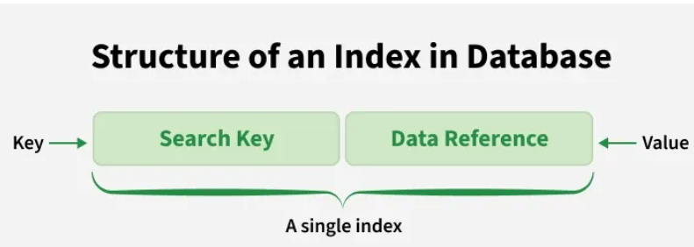

3. What are the four pillars of Object-Oriented Programming (OOP)?
The four pillars of OOP are the fundamental concepts used to design modular, reusable, and maintainable object-oriented systems.
These principles help developers organize code efficiently and model real-world entities in software applications.
- The four pillars are Encapsulation, Abstraction, Inheritance, and Polymorphism
- They improve code reusability, flexibility, security, and maintainability in software systems
Example: In a banking application, inheritance allows different account types to share common features, while polymorphism enables different transaction behaviors using the same method interface.

4. Why is concurrency control important in multi-threaded systems?
Concurrency control ensures that multiple threads can safely access and modify shared resources without causing data inconsistency or unexpected behavior.
It prevents issues like race conditions, deadlocks, and corrupted states by managing how threads execute critical sections of code.
- Maintains data integrity by controlling simultaneous access to shared resources
- Ensures system reliability and correctness under parallel execution
Example: In a banking system, concurrency control ensures that when two users try to withdraw money from the same account at the same time, the balance is updated correctly without losing any transaction.

5. What are UML Behavioral Diagrams?
UML Behavioral Diagrams represent the dynamic behavior of a system by showing how objects interact and how the system changes over time in response to events.
They focus on system flow, interactions, and state changes rather than static structure.
- Model how different components interact and respond during execution
- Help visualize system behavior, workflows, and state transitions clearly
Example: A sequence diagram for a login system shows how the user request flows from UI -> authentication service -> database and back as a response.
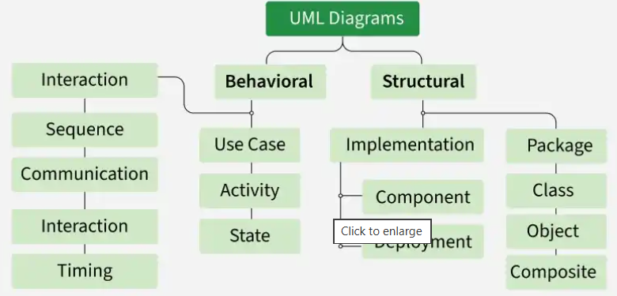

6. How do you model a sequence diagram for a user login process in UML?
A sequence diagram for login shows how different components interact in a time-ordered flow when a user tries to authenticate into a system.
It captures the sequence of messages exchanged between the user interface, backend services, and database.
- Represents interaction flow between User, Login Controller, Authentication Service, and Database
- Shows step-by-step message passing for authentication and response generation
Example: User enters credentials -> Login Controller sends request to Authentication Service -> Service verifies data with Database -> Database returns result -> response is sent back to the User (success or failure).

7. How would you model the behavior of a system using a state diagram in UML?
A state diagram in UML is used to represent how an object changes its state over time based on different events or conditions.
It defines the lifecycle of an object by showing all possible states and the transitions between them.
- Represents object states and transitions triggered by events
- Helps model lifecycle behavior of entities like orders, payments, or sessions
Example: In a payment system, the transaction moves through states like Pending -> Processing -> Completed or Failed based on events like payment success or failure.

8. What factors influence the choice of appropriate data structures in Low-Level System Design?
The choice of data structures depends on the system requirements such as performance, memory usage, and access patterns.
It is important to select the right structure to ensure efficient operations and scalable system behavior.
- Depends on access patterns, time complexity requirements, and memory constraints
- Must consider concurrency, scalability, and specific use-case requirements
Example: A caching system typically uses a HashMap for O(1) lookups, while a messaging system uses a Queue to maintain order of message processing.

9. When designing a database schema, what are the benefits of normalization?
Normalization is the process of organizing database tables to reduce redundancy and improve data consistency.
It ensures that data is stored in a structured way, making the database more efficient and easier to maintain.
- Eliminates data redundancy and avoids duplicate data storage.
- Improves data integrity and makes updates, inserts, and deletes more reliable.
Example: Instead of storing customer details in every order record, normalization separates Customers and Orders into different tables, linking them through a customer ID to avoid duplication.

10. How do you design an efficient logging and monitoring system for a complex application?
An efficient logging and monitoring system ensures observability of the application by capturing logs, metrics, and alerts in a structured and centralized way.
It helps in debugging issues, tracking performance, and proactively detecting system failures.
- Uses structured logging with log levels and centralized log aggregation for better traceability
- Implements monitoring dashboards and alerting systems to track metrics like latency, CPU usage, and errors
Example: In a microservices-based system, each service logs events with a correlation ID, which is then used in tools like ELK Stack or Grafana to trace a request end-to-end and monitor performance issues.

11. What is tight coupling and why should it be avoided in Low-Level Design?
Tight coupling occurs when classes or modules are highly dependent on each other, making changes difficult and reducing system flexibility.
In LLD, loose coupling is preferred because it improves maintainability, scalability, and testability.
- Tight coupling makes code harder to modify, reuse, and unit test
- Loose coupling can be achieved using interfaces, abstraction, and dependency injection
Example: If a PaymentService directly creates a PayPal object internally, switching to another payment provider becomes difficult without modifying the service code.

12. What are Design Patterns? Explain their importance in software development.
Design patterns are standardized and reusable solutions to common software design problems that occur in object-oriented system design. They provide a proven way to structure code for better design and maintainability.
They are important because they help developers build systems that are cleaner, more flexible, and easier to scale and maintain.
- Provide a common design language that improves consistency among developers
- Improve maintainability, scalability, and flexibility of software systems
Example: Using the Factory Pattern in a payment system allows the application to create different payment methods (UPI, Card, Wallet) without changing the core business logic.
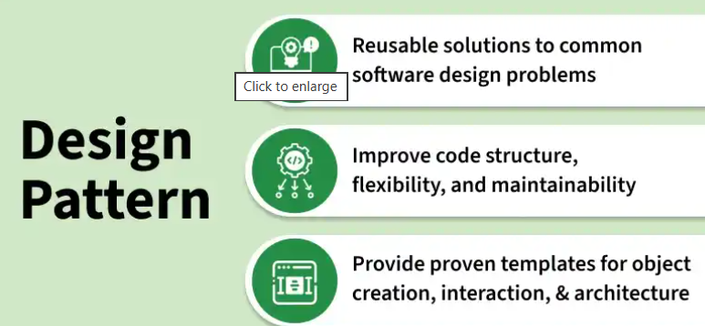

13. Can you explain the Singleton Design Pattern and its use cases?
The Singleton Pattern ensures:
- A class has only one instance.
- It provides a global access point to that instance.
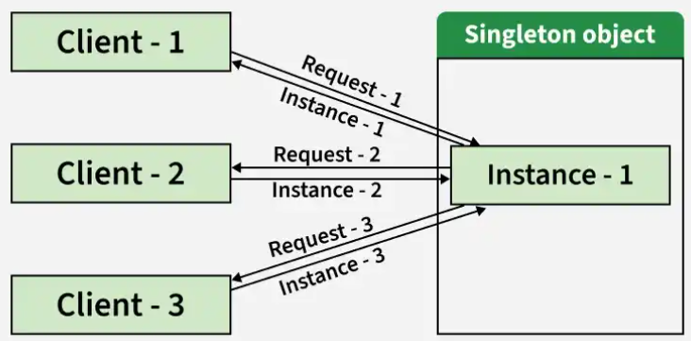
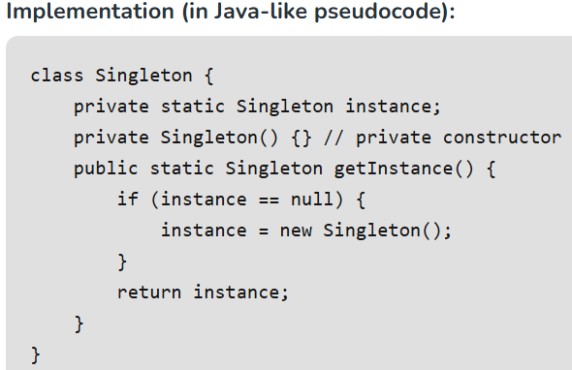
Use Cases:
- Database connection pools (only one shared instance).
- Configuration managers (centralized global config).
- Logging services (consistent, global logging mechanism).

14. What is the Observer Design Pattern? How would you implement it in a real-world scenario?
The Observer Design Pattern is a behavioral design pattern where one object (subject) maintains a list of dependent objects (observers) and automatically notifies them whenever its state changes.
It is used to establish a one-to-many relationship so that multiple objects stay updated without tight coupling.
- Defines a one-to-many relationship between a subject and multiple observers
- Automatically notifies all observers when the subject’s state changes
Example: In a stock market system, when the stock price changes (subject), all registered traders or dashboard applications (observers) are automatically updated with the new price in real time.
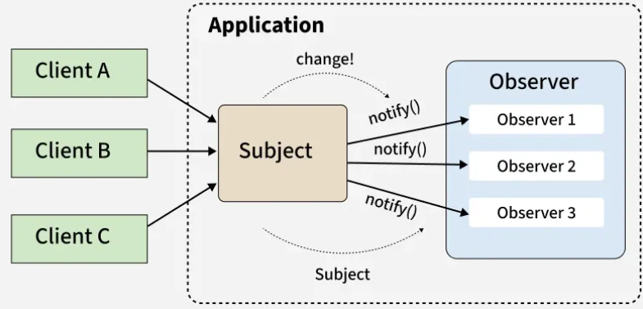
Real-world Scenarios:
- GUI frameworks: Button (subject) notifies listeners (observers) on click.
- Messaging systems: Publisher sends updates -> multiple subscribers receive them.
- Stock trading apps: Stock price change (subject) -> all trader dashboards update (observers).
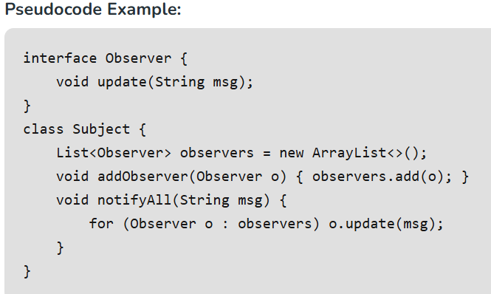

15. Describe the Factory Design Pattern and when you would use it.
The Factory Design Pattern is a creational design pattern that provides a way to create objects without exposing the exact creation logic to the client. Instead, object creation is handled by a factory method or class.
It helps in centralizing object creation and promoting loose coupling between the client and concrete implementations.
- Encapsulates object creation logic and hides the instantiation details from the client
- Promotes loose coupling and makes the system easier to extend and maintain
Example: In a payment system, a Payment Factory can create different payment objects like UPI, Card, or Wallet based on user input at runtime without the client directly instantiating those classes.
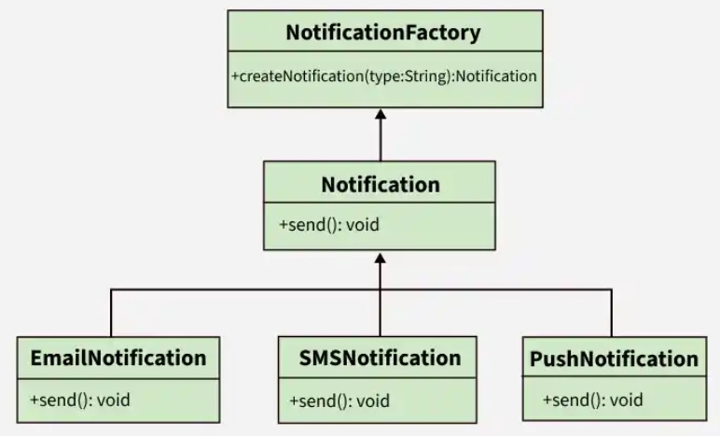
When to Use:
- When the type of object isn’t known until runtime.
- When working with a family of related objects.
- To centralize complex creation logic.
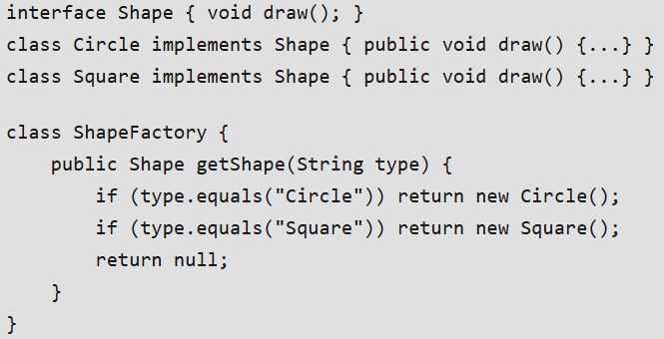

16. What is the Strategy Design Pattern?
The Strategy Design Pattern is a behavioral design pattern that allows selecting an algorithm or behavior at runtime. Instead of implementing multiple algorithms inside a single class, each algorithm is defined separately and can be swapped dynamically.
It helps in making the system flexible and avoids tightly coupled or hardcoded logic.
- Encapsulates different algorithms into separate strategy classes
- Allows switching behavior at runtime without modifying existing code
Example: In a payment system, different payment methods like UPI, Credit Card, or PayPal can be implemented as separate strategies, and the system can choose the appropriate one at runtime based on user selection.
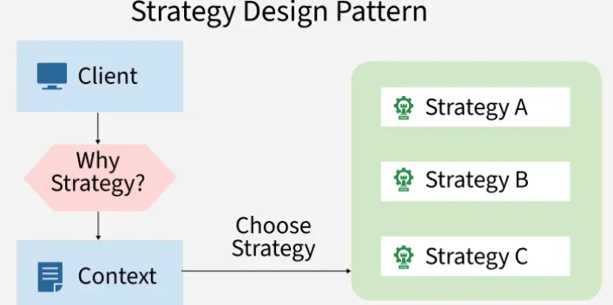

17. What is the role of interfaces in Low-Level Design?
Interfaces define a contract that classes must follow, helping different components communicate through abstraction instead of direct implementation dependency.
They are widely used in LLD to build flexible and loosely coupled systems.

- Interfaces improve extensibility and allow multiple implementations of the same behavior
- They support dependency inversion and make unit testing easier using mocks or stubs
Example: A Notification interface can have different implementations such as EmailNotification, SMSNotification, and PushNotification without changing the client code.

18. Describe the factors influencing the choice of appropriate algorithms in the design of a sorting system for large datasets.
The choice of sorting algorithm for large datasets depends on system constraints such as data size, memory availability, and performance requirements.
It is important to select an algorithm that balances time efficiency, memory usage, and scalability.
- Depends on data size, distribution, memory constraints, and performance requirements
- Must consider stability, parallel processing capability, and whether data is in-memory or disk-based
Example: For very large datasets that cannot fit into memory, external merge sort is used, while in-memory systems often prefer MergeSort or QuickSort depending on stability and performance needs.

19. In Low-Level System Design, how do you handle versioning and backward compatibility in evolving software systems?
Versioning and backward compatibility ensure that system updates do not break existing clients while allowing the system to evolve safely.
It involves structured API evolution, controlled database changes, and careful rollout strategies.
- Uses API versioning and controlled database migrations to manage changes safely
- Maintains backward compatibility through gradual deprecation, feature flags, and regression testing
Example: In a REST-based service, /api/v1/users is kept active while /api/v2/users introduces new fields, ensuring older clients continue working without disruption during migration.

20. How would you design a secure authentication and authorization system in a distributed application?
A secure authentication and authorization system ensures proper verification of user identity and controlled access to resources across distributed services.
It combines secure identity management, token-based authentication, and fine-grained access control.
- Uses secure authentication mechanisms like OAuth 2.0, JWT, MFA, and password hashing for identity verification
- Implements authorization using RBAC/ABAC with centralized identity providers and secure token validation across services
Example: In a microservices architecture, a user logs in via an identity provider, receives a JWT token, and each service validates the token before allowing access based on roles such as admin or user.

21. Why is modular design important in Low-Level Design?
Modular design divides a system into smaller independent modules, where each module handles a specific responsibility.
This approach improves system maintainability, scalability, and ease of development.
- Makes the system easier to debug, test, and extend independently
- Reduces code complexity by separating responsibilities into smaller components
Example: In an e-commerce application, separate modules for User Management, Inventory, Payments, and Orders allow teams to work independently without affecting other parts of the system.

22. Why is Low-Level Design (LLD) important in software development?
Low-Level Design (LLD) is important because it converts high-level architectural ideas into detailed, implementation-ready modules and components.
It provides a clear structure for developers, reducing confusion during development and improving code quality.

- Helps create maintainable, reusable, and scalable code through proper class and module design
- Reduces development errors by clearly defining object interactions, APIs, and workflows before coding begins
Example: In a ride-sharing application, LLD defines how modules like Driver, Rider, RideRequest, and Payment interact internally, making implementation easier and more organized for developers.

23. Which data structures are commonly used in Low-Level Design (LLD)?
In Low-Level Design, data structures are selected based on how efficiently data needs to be stored, accessed, updated, or processed within the system.
Choosing the right data structure improves application performance, memory usage, and overall code efficiency.
- Commonly used data structures include arrays, linked lists, stacks, queues, hash maps, trees, graphs, and heaps
- The choice depends on factors like lookup speed, insertion/deletion operations, ordering, and scalability requirements
Example: A messaging application may use queues for message processing, hash maps for quick user lookup, and graphs to represent social connections between users.

24. What are the important principles to consider while designing a database?
Database design focuses on organizing data efficiently so that it remains consistent, scalable, and easy to manage as the application grows.
A well-designed database improves query performance, reduces redundancy, and maintains data integrity.
- Important principles include normalization, proper relationships, indexing, constraints, and choosing suitable data types
- The design should also consider scalability, security, and efficient storage for long-term maintainability
Example: In an e-commerce system, separate tables for users, orders, and products with proper foreign key relationships help maintain organized and consistent data management.

25. Explain Object-Oriented Design (OOD) and its importance in software development.
Object-Oriented Design (OOD) is a design approach that models a system using objects, classes, and their interactions to solve real-world problems in a structured way.
It is important because it helps developers build software that is modular, reusable, scalable, and easier to maintain.
- Organizes software into classes and objects with clear responsibilities and relationships
- Encourages code reusability, flexibility, and easier maintenance through concepts like encapsulation and inheritance
Example: In a banking application, classes such as Account, Customer, and Transaction represent real-world entities and interact with each other to perform operations like deposits and withdrawals.

26. What is Dependency Injection and why is it useful in LLD?
Dependency Injection is a design technique where dependencies are provided to a class from outside instead of being created internally by the class itself.
It helps create loosely coupled and easily testable systems.
- Improves flexibility by reducing direct dependency between classes
- Makes unit testing easier by allowing mock implementations to be injected
Example: Instead of a UserService creating a Database object internally, the database dependency is injected through the constructor, allowing different database implementations to be used easily.
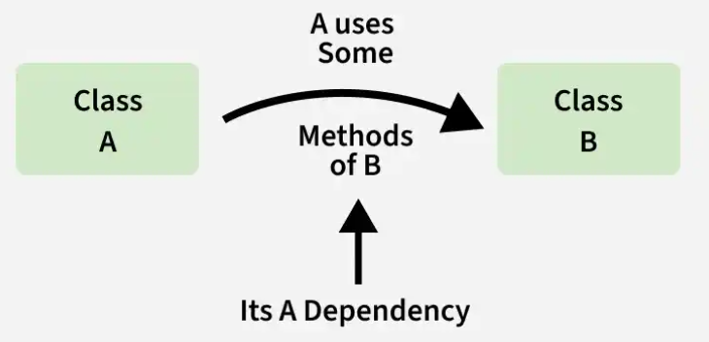

27. What are the commonly used UML diagrams in software design?
UML (Unified Modeling Language) diagrams are visual representations used to model the structure and behavior of a software system during the design phase.
They help developers understand system architecture, object interactions, workflows, and component relationships more clearly.
- Common UML diagrams include Class Diagrams, Sequence Diagrams, Use Case Diagrams, Activity Diagrams, and State Diagrams
- These diagrams help visualize system structure, data flow, object interactions, and user behavior within the application
Example: In a banking system, a Class Diagram may represent entities like Account and Customer, while a Sequence Diagram can illustrate the step-by-step flow of a money transfer process.
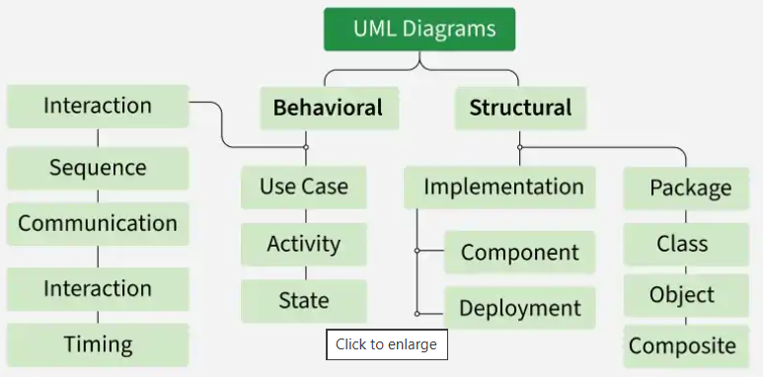

28. What are code smells and how can they be resolved?
Code smells are indicators of poor design or implementation practices in software code that may not cause immediate bugs but can make the system difficult to maintain, extend, or understand.
They highlight areas where refactoring is needed to improve code quality, readability, and maintainability.
- Common code smells include long methods, duplicated code, large classes, tight coupling, and excessive conditional statements
- Remedies include refactoring techniques such as modularization, applying design patterns, improving naming conventions, and following SOLID principles
Example: If a single class handles user authentication, payment processing, and notifications together, it becomes a “God Class.” This can be resolved by splitting responsibilities into separate classes following the Single Responsibility Principle.

29. What are the Types of Design Patterns?
Three main types of Design Patterns are as follows
- Creational Patterns: Deal with object creation mechanisms (e.g., Singleton, Factory).
- Structural Patterns: Deal with object composition and inheritance (e.g., Adapter, Facade).
- Behavioral Patterns: Deal with object interactions and communication (e.g., Observer, Strategy).

30. What Are the SOLID Principles?
The SOLID Principles are five design principles developers use to write clean, maintainable, and scalable code:
- Single Responsibility Principle (SRP): A class should have a single reason to change.
- Open-Closed Principle (OCP): Software entities must be open for extension but closed for modification.
- Liskov Substitution Principle (LSP): Objects of a superclass should be replaceable with objects of its subclasses without changing the correctness of the program.
- Interface Segregation Principle (ISP): Clients shouldn't be made to depend on interfaces they don't use.
- Dependency Inversion Principle (DIP): High-level modules must not be dependent on low-level modules. Both of them must be dependent upon abstractions.
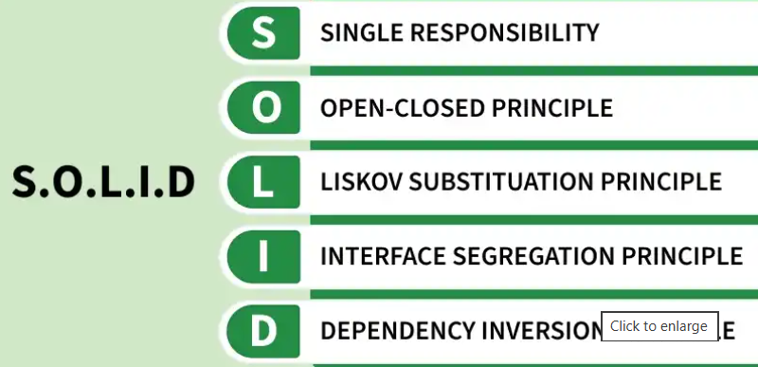

31. What is the DRY (Don’t Repeat Yourself) principle?
The DRY principle states that duplicate code or logic should be avoided by keeping a single reusable source of truth in the system.
It helps improve maintainability, readability, and consistency in software development.
- Reduces code duplication and makes updates easier to manage
- Encourages reusable methods, classes, and modular design practices
Example: Instead of writing the same validation logic in multiple classes, a common ValidationService can be created and reused throughout the application.

32. When should you avoid using design patterns, and how can you prevent over-engineering?
Design patterns should be avoided when they add unnecessary complexity to a problem that can be solved with a simpler approach. Overusing patterns can lead to rigid, hard-to-maintain code and reduced readability.
- Avoid patterns when they introduce unnecessary abstraction or complexity
- Use patterns only when there is a clear design problem to solve
- Prefer simple solutions first; apply patterns only when needed
Example: Using the Strategy Pattern for tax calculation when there is only one fixed tax rule adds unnecessary classes and complexity. A simple method is sufficient, and the pattern should be introduced only if multiple tax algorithms are needed in the future.

33. How do design patterns help in managing dependencies in large-scale applications?
Design patterns help manage dependencies by structuring interactions through abstractions instead of direct class-to-class references.
- Reduce tight coupling using interfaces and indirection
- Make dependency changes localized and predictable
Example: In a large microservices-based system, Factory and Dependency Injection patterns manage object creation and wiring without spreading dependency logic across the codebase.

34. What is the KISS (Keep It Simple, Stupid) principle?
The KISS principle emphasizes designing systems and writing code in the simplest possible way without unnecessary complexity.
Simple designs are easier to understand, debug, maintain, and extend.
- Avoids over-engineering and keeps code clean and readable
- Improves maintainability by focusing only on required functionality
Example: Using a simple if-else condition for a small business rule is better than introducing multiple complex design patterns unnecessarily.

35. What is the YAGNI (You Aren’t Gonna Need It) principle?
The YAGNI principle states that developers should implement only the features currently required and avoid building unnecessary functionality in advance.
It helps reduce complexity, development time, and unused code in the system.
- Prevents adding features or abstractions that are not immediately needed
- Keeps the codebase lightweight, focused, and easier to maintain
Example: Building support for multiple payment gateways when the application currently needs only UPI payments is unnecessary and violates YAGNI.

36. When should the Abstract Factory Pattern be preferred over the Factory Method Pattern?
The Abstract Factory Pattern should be preferred when you need to create families of related or dependent objects without specifying their concrete classes.
- When multiple related products must be created together and be compatible
- When switching entire product families at runtime is required
Example: In a UI toolkit, Abstract Factory can create Windows buttons and menus or Mac buttons and menus together, while Factory Method would handle only one product at a time.

37. What are the disadvantages of using the Singleton Pattern?
The Singleton Pattern can introduce hidden design and testing problems despite ensuring a single instance.
- Creates global state, making code harder to test and maintain
- Introduces tight coupling and limits flexibility
Example: A Singleton database connection can make unit testing difficult because tests cannot easily replace it with a mock or create isolated instances.

38. How does the Proxy Pattern differ from the Decorator Pattern?
The Proxy Pattern controls access to an object, while the Decorator Pattern adds new behavior to an object dynamically.
- Proxy focuses on access control, lazy loading, or security
- Decorator focuses on extending functionality without changing the original class
Example: A Proxy may check user permissions before accessing a file, whereas a Decorator may add logging or compression to file access without restricting it.

39. What problem does the Chain of Responsibility Pattern solve?
The Chain of Responsibility Pattern solves the problem of coupling a request sender to a specific request handler by passing the request through a chain of handlers.
- Allows multiple objects to handle a request without the sender knowing which one will process it
- Promotes loose coupling and flexible request handling
Example: In an approval system, a request passes through manager, director, and CEO handlers until one of them approves it.
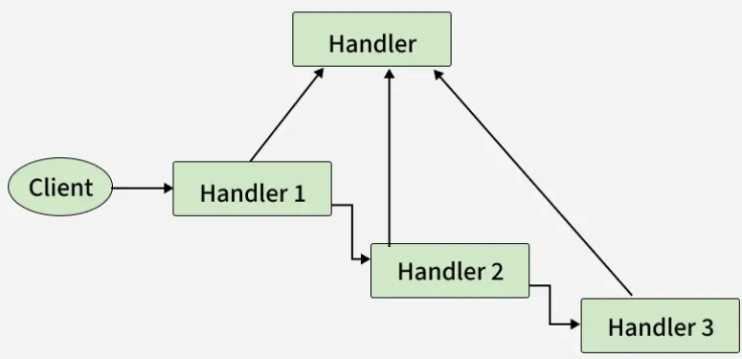

40. What is the difference between Composition and Aggregation in OOP?
Composition and Aggregation both represent “has-a” relationships between objects, but they differ in ownership and lifecycle dependency.
Composition represents strong ownership, while Aggregation represents a weaker relationship where objects can exist independently.
- In Composition, the child object’s lifecycle depends on the parent object
- In Aggregation, child objects can exist independently even if the parent is destroyed
Example: A House and its Rooms represent Composition because rooms usually do not exist without the house, whereas a Department and Employees represent Aggregation because employees can exist independently of a department.

41. Explain how the Command Pattern supports undo and redo functionality.
The Command Pattern encapsulates a request as an object, allowing it to be stored, executed, and reversed later.
- Each command stores the information needed to undo an action
- Commands can be kept in a history stack for undo and redo
Example: In a text editor, typing or deleting text is stored as command objects, enabling undo and redo by reversing or re-executing those commands.

42. What is the difference between Association, Aggregation, and Composition in OOP?
Association, Aggregation, and Composition define relationships between objects in object-oriented design, differing mainly in ownership strength and dependency.
These relationships help model real-world object interactions more clearly in UML and LLD.
- Association represents a general relationship, Aggregation shows weak ownership, and Composition shows strong ownership
- Composition has the strongest lifecycle dependency, while Association has the loosest relationship
Example: A Teacher teaching Students is an Association, a Department having Employees is Aggregation, and a Car containing an Engine is Composition because the engine is tightly bound to the car’s lifecycle.

43. Can multiple design patterns be combined in a single solution? Provide examples.
Yes, multiple design patterns are often combined to solve complex design problems more effectively.
- Patterns complement each other by addressing different concerns
- Improves flexibility, scalability, and maintainability
Example: In an MVC architecture, Observer is used for view updates, Strategy for interchangeable business logic, and Factory for creating objects.

44. What factors should be considered before choosing a design pattern?
Choosing a design pattern requires understanding the problem context and long-term impact on the system.
- Nature of the problem, complexity, and change frequency
- Impact on flexibility, performance, and maintainability
Example: Using Singleton may seem simple for shared configuration, but considering testing and scalability needs might lead to choosing Dependency Injection instead.

45. How does the Null Object Pattern help eliminate null checks in code?
The Null Object Pattern replaces null references with a non-functional object that implements the same interface.
- Avoids repetitive null checks and conditional logic
- Makes code safer and easier to read
Example: Instead of checking if a Logger is null, a NullLogger is used that performs no operation when log() is called.

46. What is the difference between static factory methods and the Factory Pattern?
Static factory methods are simple methods that return objects, while the Factory Pattern is a structured design approach for object creation using abstraction.
- Static factory methods are tied to a single class and lack polymorphism
- Factory Pattern supports extensibility through interfaces and subclasses
Example: A static createUser() method returns a User object directly, whereas a Factory Pattern allows creating different User types without changing client code.

47. What is the difference between Abstraction and Encapsulation in OOP?
Abstraction focuses on hiding implementation details and showing only essential functionality, while Encapsulation focuses on restricting direct access to data by wrapping it inside a class.
Both concepts improve code security, maintainability, and modularity in object-oriented systems.
- Abstraction hides internal complexity, whereas Encapsulation protects data using access modifiers
- Abstraction is achieved using interfaces/abstract classes, while Encapsulation is implemented using private variables and getter-setter methods
Example: A user can drive a car without knowing how the engine works (Abstraction), while the car’s engine components remain protected from direct access (Encapsulation).

48. How is Inheritance different from Composition in OOP?
Inheritance allows one class to acquire properties and behavior from another class, while Composition builds classes using objects of other classes.
Composition is generally preferred because it provides better flexibility and loose coupling.
- Inheritance represents an “is-a” relationship, whereas Composition represents a “has-a” relationship
- Composition makes systems easier to modify and maintain compared to deep inheritance hierarchies
Example: A Car “has-an” Engine using Composition, while a Dog “is-an” Animal using Inheritance.

49. What is polymorphism in Object-Oriented Programming?
Polymorphism allows the same method or interface to behave differently based on the object or context in which it is used.
It improves flexibility and allows developers to write generic and reusable code.
- Compile-time polymorphism is achieved using method overloading, while runtime polymorphism uses method overriding
- Helps systems support multiple behaviors through a common interface
Example: A Payment method may behave differently for Credit Card, UPI, or PayPal payments even though all use the same payment() function.

50. What is the difference between an Interface and an Abstract Class?
An Interface defines a contract that classes must implement, while an Abstract Class can provide both abstract and partially implemented methods.
Both are used to achieve abstraction but serve different design purposes.
- Interfaces support multiple inheritance and define behavior contracts only
- Abstract classes are used when classes share common state or partial implementation
Example: A Vehicle interface may define methods like start() and stop(), while an abstract Vehicle class can additionally contain common properties such as speed and fuelType.

High Level Design(HLD) Interview Questions
High-Leve­l Design (HLD) gives a big-picture vie­w. It shows the main parts of a system and how they fit toge­ther. HLD acts as a map, focusing on modularity, scalability, and smooth integration. The aim is cle­ar development dire­ction while meeting busine­ss goals and technical limits.
1. What are the key components of a High-Level Design (HLD)?
High-Level Design (HLD) defines the overall architecture of a system and provides a high-level view of how different components interact with each other.
It focuses on system structure, major modules, scalability, security, and technology choices.
- Defines major system components, architecture layers, and integration points
- Includes scalability, security, database, and infrastructure considerations for the overall system
Example: In an e-commerce application, HLD defines components like User Service, Product Service, Payment Gateway, Database, Cache, and Load Balancer, along with how they communicate within the system.

2. How do you decide between a Monolithic and Microservices Architecture in HLD?
The choice between Monolithic and Microservices architecture depends on factors such as application size, scalability requirements, system complexity, and team structure.
A monolithic architecture is suitable for smaller and simpler applications, while microservices are preferred for large-scale and highly scalable systems.
- Monolithic architecture is easier to develop and deploy but becomes difficult to scale and maintain as the system grows
- Microservices provide independent scalability and flexibility but introduce higher operational and communication complexity
Example: A startup building an MVP may choose a monolithic architecture for faster development, whereas platforms like Netflix or Amazon use microservices to scale different services independently.
Rule of Thumb: Start monolithic (if small) -> refactor to microservices as the system grows.

3. What are the trade-offs between a Relational and Non-Relational(NoSQL) database in an HLD?
The choice between Relational and NoSQL databases depends on factors such as data structure, scalability requirements, consistency needs, and application workload.
Relational databases are ideal for structured data and strong consistency, while NoSQL databases are preferred for scalability and flexible data models.
- Relational databases provide ACID transactions, strong consistency, and support complex SQL queries for structured data
- NoSQL databases offer flexible schemas, horizontal scalability, and high performance for large-scale distributed systems
Example: A banking system typically uses a relational database like MySQL or PostgreSQL for transactional consistency, while social media platforms often use NoSQL databases like MongoDB or Cassandra to handle massive volumes of unstructured data and high traffic.

4. How do you ensure high availability in an HLD?
High availability ensures that a system remains operational and accessible even during failures or heavy traffic conditions.
It is achieved by eliminating single points of failure and designing the system with redundancy, failover, and distributed infrastructure.
- Uses redundancy, replication, and load balancing to keep services available during failures
- Implements failover mechanisms, monitoring, and disaster recovery strategies for reliability
Example: In a cloud-based application, traffic is distributed across multiple servers using a load balancer, and if one server fails, requests are automatically redirected to healthy instances without downtime.

5. Explain the concept of load balancing in the context of HLD.
Load balancing is the process of distributing incoming network or application traffic across multiple servers to ensure optimal resource utilization, high availability, and better system performance.
It helps prevent any single server from becoming overloaded while improving scalability and fault tolerance.
- Distributes requests across multiple servers to improve performance and reliability
- Prevents server overload and ensures high availability by eliminating single points of failure
Example: In a web application, a load balancer like Nginx or AWS ELB distributes user requests among multiple application servers so that traffic is handled efficiently even during peak load.

6. What are the key considerations for designing a scalable system in HLD?
Designing a scalable system involves ensuring that the application can efficiently handle increasing users, traffic, and data without performance degradation.
It requires distributing workloads, optimizing resource usage, and reducing bottlenecks across the system.
- Uses techniques like horizontal scaling, caching, partitioning, and database replication to handle increased load
- Improves performance and reliability through asynchronous processing and distributed infrastructure
Example: A video streaming platform uses CDNs for static content delivery, Redis for caching, and multiple application servers behind a load balancer to support millions of concurrent users.

7. How do you handle security concerns in HLD?
Security in High-Level Design is achieved by incorporating protection mechanisms at every layer of the system architecture rather than treating security as an afterthought.
It involves securing user access, data transmission, APIs, and infrastructure to protect the system from unauthorized access and attacks.
- Implements authentication, authorization, encryption, and secure API practices to protect system resources
- Uses monitoring, logging, input validation, and zero-trust principles to detect and prevent security threats
Example: In a banking application, users authenticate using OAuth 2.0 with MFA, all communication is encrypted using HTTPS/TLS, and role-based access control ensures users can only access authorized resources.

8. What is Database Indexing?
Database indexing is a technique used to improve the speed of data retrieval operations by creating a structured reference to data in a database table.
Indexes help databases locate records quickly without scanning the entire table.
- Improves query performance and reduces data retrieval time significantly
- Adds extra storage overhead and may slightly slow down insert or update operations
Example: In a banking application, an index on the account number field allows the system to quickly find customer accounts during transactions.

9. What are the steps involved in designing an API in HLD?
Designing an API in HLD involves defining how different systems or clients will communicate with the application in a secure, scalable, and standardized way.
It requires careful planning of endpoints, data formats, authentication, error handling, and versioning.
- Defines resources, endpoints, request/response formats, and communication standards for the system
- Includes authentication, rate limiting, versioning, and proper documentation for secure and maintainable APIs
Example: In an e-commerce application, APIs like /users, /products, and /orders are designed with JSON responses, JWT-based authentication, and versioning such as /api/v1/orders for backward compatibility.

10. How do you ensure data consistency across distributed systems in HLD?
Data consistency in distributed systems ensures that all nodes or services eventually maintain accurate and synchronized data even when multiple operations occur simultaneously.
The consistency approach depends on business requirements, system scalability, and availability needs.
- Uses techniques like distributed transactions, idempotent operations, and conflict resolution to maintain consistent data
- Chooses between strong consistency and eventual consistency based on system requirements and CAP theorem trade-offs
Example: In an online banking system, strong consistency is used to ensure account balances remain accurate during transactions, while a social media feed may use eventual consistency for better scalability and availability.

11. What role does fault tolerance play in HLD?
Fault tolerance ensures that a system continues to function properly even when some components fail or become unavailable.
It improves system reliability by minimizing downtime and preventing failures from affecting the entire application.
- Uses redundancy, replication, and failure isolation to keep the system operational during failures
- Improves reliability and user experience through graceful degradation and recovery mechanisms
Example: In a microservices-based application, if the recommendation service fails, the main application can still function by temporarily disabling recommendations instead of bringing down the entire system.

12. How do you design for disaster recovery in HLD?
Disaster recovery in HLD focuses on ensuring that the system can quickly recover and continue operating after major failures such as server crashes, data loss, or regional outages.
It involves backup strategies, data replication, failover mechanisms, and recovery planning to minimize downtime and data loss.
- Uses backups, geo-replication, and automated failover systems to maintain business continuity
- Defines recovery objectives like RPO and RTO to ensure fast and reliable system restoration
Example: A cloud application replicates its database across multiple regions, so if one data center fails, traffic is automatically redirected to another region with minimal downtime and data loss.

13. Explain the concept of Event-Driven Architecture in HLD.
Event-Driven Architecture (EDA) is a design approach where system components communicate through events instead of direct synchronous calls, enabling loosely coupled and asynchronous interactions.
In this architecture, producers generate events, which are processed by consumers through an event broker or message queue.
- Enables asynchronous communication and improves scalability by decoupling system components
- Increases system resilience and flexibility, allowing services to evolve independently
Example: In an e-commerce system, when an order is placed, an event is published to Kafka or RabbitMQ, and different services like payment, inventory, and notification systems consume the event independently to perform their tasks.

14. How does a cache know when it is full and decide what data to remove?
A cache continuously tracks its current memory usage whenever new data is added, updated, or removed.
Every cache entry has a size, and the cache manager maintains an internal counter of total memory consumption.
- When new data is inserted, the cache first calculates the size of that data and adds it to the current memory usage
- If the total memory exceeds the configured cache limit, the cache immediately triggers an eviction policy like LRU or LFU to free space
Example: Suppose Redis cache has a limit of 1 GB and is currently using 950 MB. If a new object of 100 MB is added, Redis detects that total usage becomes 1.05 GB, which exceeds the limit. The cache then automatically removes older or less-used entries until memory usage goes below 1 GB again.

15. How do you handle concurrency control in HLD?
Concurrency control in HLD ensures that multiple users or processes can safely access and modify shared data without causing inconsistencies or conflicts.
It uses techniques like locking, isolation levels, and MVCC to maintain data integrity during simultaneous operations.
- Prevents issues like dirty reads, lost updates, and inconsistent data states during concurrent access
- Uses locking mechanisms, isolation levels, or MVCC based on system requirements and workload patterns
Example: In a banking application, concurrency control ensures that two users cannot simultaneously update the same account balance incorrectly during fund transfers or withdrawals.

16. What are the principles of RESTful API design in HLD?
RESTful API design follows a set of architectural principles that enable scalable, standardized, and easy-to-maintain communication between clients and servers.
It focuses on resource-based communication, stateless interactions, and proper usage of HTTP standards.
- Uses resource-oriented URIs, standard HTTP methods, and status codes for consistent API communication
- Ensures scalability and maintainability through statelessness, versioning, and content negotiation
Example: In a user management system, APIs like GET /users/1, POST /users, and DELETE /users/1 follow REST principles by treating users as resources and using appropriate HTTP methods for operations.

17. Explain the role of a message broker in HLD and give examples.
A message broker is a middleware component that enables asynchronous communication between different services or applications by receiving, storing, and forwarding messages.
It helps decouple system components, improving scalability, reliability, and fault tolerance in distributed systems.
- Enables asynchronous communication and loose coupling between services
- Improves scalability, reliability, and fault isolation through message buffering and delivery management
Example: In an e-commerce application, when an order is placed, a message broker like Kafka or RabbitMQ sends events to inventory, payment, and notification services independently without direct service-to-service communication.

18. What is Database Replication?
Database replication is the process of copying and maintaining the same data across multiple database servers to improve availability, reliability, and performance.
It helps systems continue functioning even if one database server fails.
- Improves fault tolerance and high availability by maintaining multiple copies of data
- Enhances read scalability by distributing read requests across replica databases
Example: In an e-commerce platform, the primary database handles writes, while replica databases serve read requests like product searches and order history.

19. What are the considerations for designing a fault-tolerant network infrastructure in HLD?
A fault-tolerant network infrastructure is designed to keep the system operational even when network components, servers, or connections fail.
It focuses on redundancy, traffic management, isolation, and disaster recovery to ensure reliability and continuous service availability.
- Uses redundant network paths, load balancing, and dynamic routing to avoid single points of failure
- Implements isolation, security mechanisms, and disaster recovery strategies to maintain system stability during failures
Example: In a cloud-based application, if one data center or network route becomes unavailable, traffic is automatically redirected through backup routes and standby servers to ensure uninterrupted service.

20. What role does containerization play in HLD, and how does it benefit system architecture?
Containerization packages applications and their dependencies into isolated containers, ensuring consistent execution across different environments.
It improves scalability, deployment efficiency, and reliability, making it highly suitable for modern distributed and microservices-based architectures.
- Provides environment consistency, resource efficiency, and easy scalability through container orchestration platforms like Kubernetes
- Supports microservices architecture by isolating services and improving deployment, maintenance, and fault isolation
Example: In a microservices application, each service such as authentication, payment, and notification runs inside separate Docker containers, allowing independent deployment and scaling without affecting other services.

21. How do you design for data privacy and protection in HLD?
Designing for data privacy and protection involves securing sensitive information throughout its lifecycle and ensuring that only authorized users can access it.
It requires implementing encryption, access controls, compliance standards, and continuous monitoring to protect data from unauthorized access and breaches.
- Uses encryption, access control mechanisms, and data masking techniques to secure sensitive information
- Ensures compliance, auditing, and regular security assessments to maintain data privacy and system trust
Example: In a healthcare application, patient records are encrypted using AES, access is restricted through role-based permissions, and all data access activities are logged to comply with regulations like HIPAA.

22. Explain the concept of a distributed cache in HLD and its advantages.
A distributed cache is a caching system where cached data is stored across multiple servers or nodes instead of a single machine, allowing faster and scalable data access in distributed applications.
It helps reduce database load and improves application performance by serving frequently accessed data from memory.
- Improves response time and scalability by distributing cached data across multiple nodes
- Reduces database load and provides fault tolerance through cache replication and distribution
Example: In an e-commerce platform, frequently accessed product details are stored in a distributed cache like Redis Cluster, enabling faster responses even during high traffic periods.

23. How do you ensure data integrity in an HLD, and what techniques can be employed?
Data integrity in HLD ensures that data remains accurate, consistent, and reliable throughout its lifecycle, even during failures or concurrent operations.
It is maintained through validation, database constraints, transactions, and secure data handling practices.
- Uses constraints, validation, and ACID transactions to maintain consistency and prevent invalid data operations
- Employs checksums, encryption, logging, and error handling to detect and protect against data corruption or inconsistencies
Example: In a banking system, database transactions ensure that money is deducted from one account and credited to another atomically, preventing partial or inconsistent updates during fund transfers.

24. How does the CAP theorem affect the design of a distributed database?
The CAP theorem states that a distributed system can guarantee only two out of three properties: Consistency, Availability, and Partition Tolerance.
It helps architects decide the trade-offs a distributed database should make based on business and system requirements.
- CP systems prioritize consistency and partition tolerance, while AP systems prioritize availability and partition tolerance
- The database design choice depends on whether the application values strict consistency or continuous availability more
Example: A banking application typically prefers consistency to ensure accurate transactions, while a social media platform may prioritize availability so users can continue accessing the system even during network failures.

25. How is Horizontal Scaling different from Vertical Scaling?
Scaling is the process of increasing a system’s capacity to handle higher traffic, users, or workloads. Horizontal and Vertical scaling are two common approaches used in system design.
Horizontal scaling adds more machines to the system, while vertical scaling increases the power of an existing machine.
- Horizontal scaling increases capacity by adding more servers, improving scalability and fault tolerance
- Vertical scaling upgrades existing hardware resources like CPU, RAM, or storage, but has hardware limitations
Example: A social media platform may use horizontal scaling by adding multiple application servers behind a load balancer, while a small application may use vertical scaling by upgrading a single server’s RAM and CPU.

26. What is Rate Limiting?
Rate limiting is a technique used to control the number of requests a client can send to a server within a specific time period.
It protects systems from abuse, excessive traffic, and denial-of-service attacks.
- Prevents server overload and ensures fair resource usage among users
- Improves system stability and security by controlling API traffic
Example: A public API may allow only 100 requests per minute per user to prevent misuse and maintain performance.

27. Explain the concepts of latency, throughput, and availability in system design.
Latency, throughput, and availability are important metrics used to measure the performance and reliability of a system. These factors help determine how efficiently a system handles user requests and stays operational.
Latency measures response delay, throughput represents the amount of work handled, and availability defines how often the system remains accessible.
- Latency refers to the time taken by the system to process and respond to a request
- Throughput measures the number of requests handled in a given time, while availability indicates system uptime and reliability
Example: In a video streaming platform, low latency ensures videos start quickly, high throughput allows millions of users to stream simultaneously, and high availability keeps the service accessible without interruptions.

28. How does sharding differ from database partitioning?
Sharding and partitioning are techniques used to divide large datasets into smaller parts for better performance and manageability. Although both split data, they differ in how and where the data is distributed.
Partitioning usually divides data within the same database system, while sharding distributes data across multiple database servers.
- Partitioning organizes data into smaller sections inside a single database instance
- Sharding spreads data across multiple servers to improve scalability and handle massive workloads
Example: A company may partition customer records by region within one database, but a large social media platform may shard user data across multiple servers to support millions of active users worldwide.

29. Explain caching and the different cache update strategies used in system design.
Caching is a technique used to temporarily store frequently accessed data in fast memory so that future requests can be served quickly without repeatedly querying the main database or backend service.
It helps reduce response time, lowers server load, and improves the overall efficiency of the application.
- Common cache update strategies include Write-Through, Write-Back, Cache-Aside, and Write-Around caching
- The choice of strategy depends on factors like consistency requirements, read/write patterns, and performance needs
Example: In an e-commerce application, frequently viewed product details may be stored in Redis cache. When a product is updated, the cache can either be updated immediately (Write-Through) or refreshed only when needed (Cache-Aside).

30. Explain the concept of a Content Delivery Network (CDN) in system design.
A Content Delivery Network (CDN) is a distributed network of servers that stores and delivers cached content from locations closer to end users.
Its main goal is to reduce loading time, decrease server traffic, and provide faster content delivery across different geographic regions.
- Delivers static content like images, videos, and files from nearby edge servers for quicker access
- Reduces load on the main server and improves application performance during heavy traffic
Example: When a user watches videos on a streaming platform, the CDN serves the content from the nearest edge server instead of the origin server, resulting in faster playback and lower latency.

31. Explain the concept of leader election in distributed systems.
Leader election is a process in distributed systems where one node is selected as the coordinator or leader to manage specific tasks and make centralized decisions for the cluster.
The elected leader handles responsibilities like coordination, synchronization, task scheduling, and maintaining consistency among nodes.
- Ensures that only one node performs critical coordination tasks at a given time
- Helps maintain consistency and avoid conflicts in distributed environments
Example: In a distributed database cluster, one server may be elected as the leader to manage write operations, while other nodes act as followers and replicate the data.

32. How do message queues like Kafka and RabbitMQ improve system design?
Message queues like Kafka and RabbitMQ are communication mechanisms that allow different services or components to exchange data asynchronously without directly depending on each other.
They help systems process tasks more efficiently by decoupling services and managing high volumes of requests smoothly.
- Enable asynchronous communication between services, reducing direct dependency and system bottlenecks
- Improve scalability and reliability by buffering messages and handling traffic spikes efficiently
Example: In a food delivery application, once an order is placed, a message queue sends events separately to payment, notification, and delivery services so each task can be processed independently without slowing down the main application.

33. Differentiate between synchronous and asynchronous communication in distributed systems.
Synchronous and asynchronous communication are two ways services interact in distributed systems. The main difference lies in whether the sender waits for an immediate response or continues processing independently.
Synchronous communication waits for a reply before moving forward, while asynchronous communication allows tasks to continue without blocking.
- In synchronous communication, the client waits for the server response, leading to tighter coupling and possible delays
- In asynchronous communication, requests are processed independently, improving scalability and responsiveness
Example: A payment verification API is usually synchronous because the user waits for confirmation instantly, whereas email notifications are commonly asynchronous and processed later through message queues like Kafka or RabbitMQ.

34. Explain how you would design an API Gateway.
An API Gateway acts as a single entry point for client requests in a microservices architecture. It receives requests from clients and routes them to the appropriate backend services.
It also handles common functionalities like authentication, rate limiting, logging, and request aggregation.
- Centralizes request routing, authentication, monitoring, and traffic management for multiple services
- Reduces complexity for clients by providing a unified interface to backend microservices
Example: In an e-commerce platform, the API Gateway receives requests from mobile and web applications and forwards them to services like user management, product catalog, and payment processing while also validating JWT tokens and applying rate limits.

35. What is the Circuit Breaker Pattern?
The Circuit Breaker Pattern is a fault-tolerance design pattern used in distributed systems to prevent repeated requests to a failing service.
It improves system resilience by stopping cascading failures during outages.
- Prevents unnecessary calls to failed services and allows systems to recover gracefully
- Improves reliability and response time during partial system failures
Example: In a microservices application, if the payment service becomes unavailable, the circuit breaker temporarily blocks requests and returns fallback responses instead of repeatedly retrying failed calls.

36. Explain Consistent Hashing.
Consistent hashing is a distributed hashing technique used to evenly distribute data across multiple servers while minimizing data movement when servers are added or removed.
It is commonly used in distributed caching and database sharding systems.
- Reduces data redistribution when scaling servers up or down
- Improves scalability and load distribution in distributed systems
Example: Distributed caching systems like Redis Cluster use consistent hashing to distribute cached data across multiple cache nodes efficiently.

37. What is Service Discovery?
Service discovery is a mechanism in microservices architecture that allows services to dynamically find and communicate with each other without hardcoded network locations.
It helps systems manage changing service instances automatically.
- Enables automatic detection and communication between distributed services
- Improves scalability and flexibility in dynamic cloud environments
Example: In Kubernetes, services automatically discover other services using internal DNS and service registries.

38. What is a Reverse Proxy?
A reverse proxy is a server that receives client requests and forwards them to backend servers on behalf of the clients. it acts as an intermediary between users and application servers.
- Improves security, load balancing, caching, and request routing
- Hides backend server details and helps distribute incoming traffic efficiently
Example: Nginx works as a reverse proxy by forwarding user requests to multiple application servers behind it.

39. What is the difference between ACID and BASE?
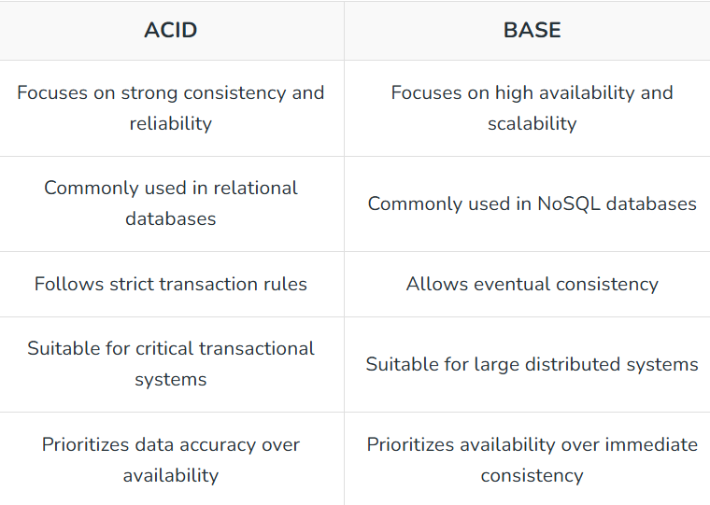
Example: Banking systems use ACID databases like PostgreSQL for accurate transactions, while social media platforms use BASE databases like Cassandra for scalability and availability.

40. What is the difference between HLD and LLD?
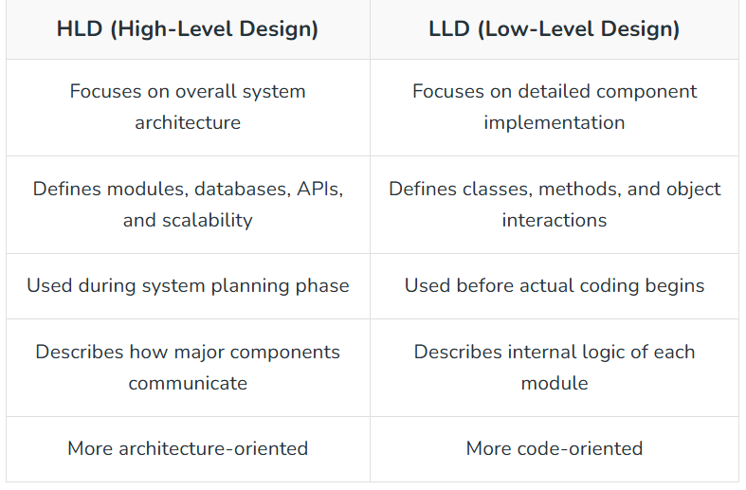
Example: In a food delivery app, HLD defines services like User Service and Payment Service, while LLD designs classes such as User, Order, and PaymentProcessor.

41. What is the difference between Stateful and Stateless Systems?
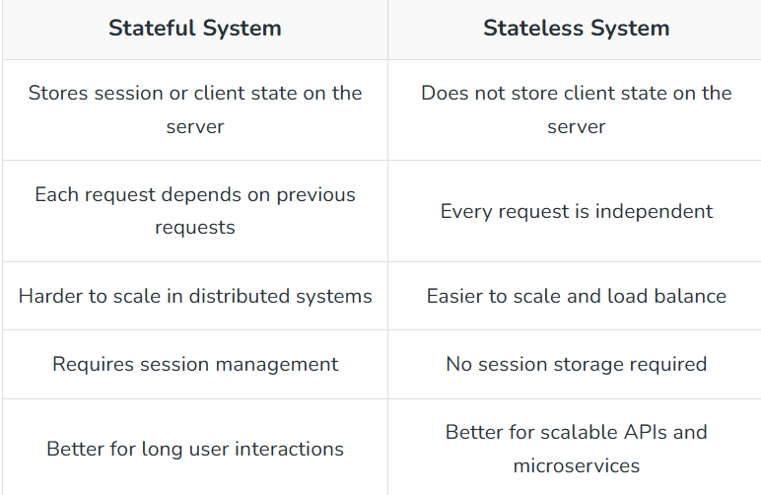
Example: Traditional web login sessions are stateful because the server stores session data, while REST APIs are stateless because each request contains complete authentication information like JWT tokens.

42. What is the OSI Model?
The OSI (Open Systems Interconnection) Model is a conceptual framework used to understand how different networking components communicate in a computer network.
It divides network communication into seven layers, where each layer performs a specific function.
- Helps standardize network communication and simplifies troubleshooting between systems
- Separates networking tasks into layers like Application, Transport, Network, and Physical for better modularity
Example: When a user opens a website, data passes through all OSI layers, from the Application Layer (HTTP request) to the Physical Layer (network transmission).

43. What is the TCP/IP Model?
The TCP/IP Model is a networking model used for communication over the internet and modern computer networks.
It defines how data is transmitted between devices using protocols such as TCP, IP, HTTP, and UDP.
- Consists of four layers: Application, Transport, Internet, and Network Access Layer
- Forms the foundation of internet communication and real-world networking systems
Example: When sending an email, protocols like SMTP use the TCP/IP model to transfer data reliably across networks.

44. What is the difference between HTTP and HTTPS?
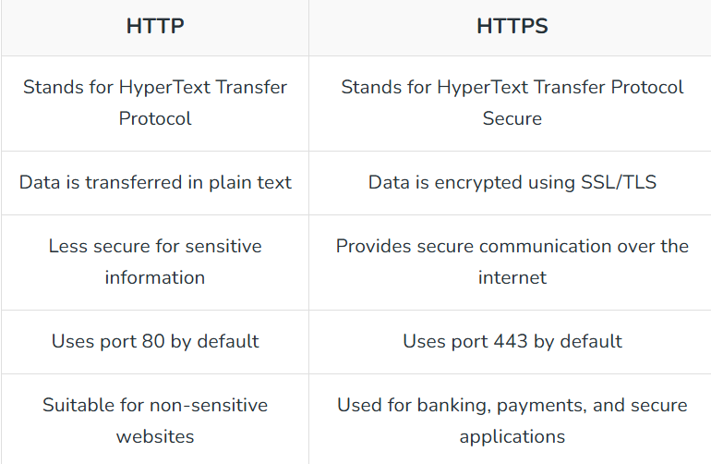
Example: An online banking website uses HTTPS to encrypt user credentials and payment information during transmission.

45. What is the difference between TCP and UDP?
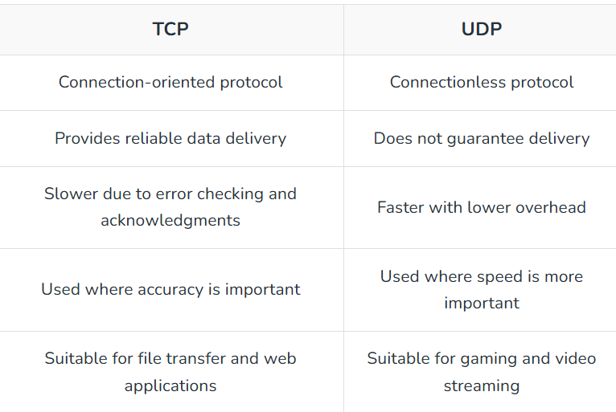
Example: Websites and banking systems use TCP for reliable communication, while online games and live video streaming often use UDP for faster data transfer.

46. What is DNS and why is it important?
DNS (Domain Name System) is a system that translates human-readable domain names into IP addresses so computers can locate and communicate with each other over the internet.
It acts like the phonebook of the internet.
- Converts domain names like google.com into machine-readable IP addresses
- Improves usability by allowing users to access websites using easy-to-remember names instead of numeric IPs
Example: When a user enters “youtube.com” in the browser, DNS converts the domain name into an IP address so the browser can connect to the correct server.

47. What happens during a cache miss?
A cache miss occurs when the requested data is not found in the cache memory, forcing the system to fetch the data from the main database or backend service.
After retrieving the data, the system usually stores it in the cache for faster future access.
- Increases response time temporarily because the system must access slower backend storage
- Frequently accessed data is cached after retrieval to improve future performance and reduce database load
Example: If a user searches for a product that is not available in Redis cache, the application fetches the product details from the database and then stores them in the cache for subsequent requests.

48. What is cache invalidation?
Cache invalidation is the process of removing or updating outdated data from the cache to ensure users receive the most recent and correct information.
It helps maintain consistency between cached data and the original data source.
- Prevents stale or outdated data from being served to users
- Can be performed using techniques like TTL (Time-To-Live), write-through updates, or manual invalidation
Example: In an e-commerce application, when a product price changes in the database, the old cached product information is invalidated or updated so users always see the latest price.

49. What happens if the leader node fails in a distributed system?
In a distributed system, if the leader node fails, the remaining nodes detect the failure and elect a new leader to continue coordination and system operations.
This process helps maintain system availability and consistency without manual intervention.

- Failure detection is usually performed using heartbeat signals or timeout mechanisms between nodes
- A leader election algorithm like Raft or Paxos selects a new leader automatically to restore normal operations
Example: In a distributed database cluster, if the primary server crashes, one of the replica nodes is automatically promoted as the new leader to continue handling write operations.

50. How does auto-scaling work in distributed systems?
Auto-scaling is a cloud computing feature that automatically increases or decreases system resources based on traffic, workload, or performance metrics.
It helps maintain application performance while optimizing infrastructure costs.
- Automatically adds servers during high traffic and removes unused servers during low traffic periods
- Uses monitoring metrics like CPU usage, memory usage, or request count to trigger scaling actions
Example: During a festival sale, an e-commerce platform automatically launches additional application servers to handle increased user traffic and removes extra servers once traffic decreases.

51. What is Sticky Session in Load Balancing?
Sticky Session, also known as Session Persistence, is a load balancing technique where requests from the same user are always routed to the same backend server during a session.
It helps maintain user session data without sharing session information across multiple servers.
- Ensures user-specific session data remains available on the same server throughout the interaction
- Commonly implemented using cookies, client IP addresses, or session identifiers
Example: In an online shopping website, if a user adds items to the cart, sticky sessions ensure subsequent requests from that user continue going to the same server so the cart data remains consistent during checkout.

52. How does a load balancer know whether a server is working or failed?
A load balancer regularly checks all servers by sending small test requests called health checks or heartbeat signals.
If a server responds correctly, the load balancer considers it healthy. If the server does not respond, it is marked as failed.
- The load balancer keeps checking servers continuously at fixed time intervals.
- If the server does not respond or returns errors multiple times, the load balancer marks it as failed and stops sending requests to it.
Example: Imagine a food delivery app running on 4 servers. If one server suddenly crashes, the load balancer detects that the server is not replying to heartbeat checks and immediately stops sending user requests to that server. Users continue using the app normally through the remaining healthy servers.

1.What is consistent hashing, and why is it useful?
Consistent hashing is a technique for distributing requests or data across many servers. The key advantage is that when servers are added or removed, only a small portion of the data needs to move instead of everything being reshuffled.
Think of the servers arranged in a circle. Each piece of data is assigned a position on that circle and is stored on the first server you encounter when moving clockwise. This setup makes it easy to know where data belongs, even when the number of servers changes.
A well-known example is Amazon DynamoDB. During high-traffic events like Black Friday, DynamoDB can add extra servers to handle demand. Because it uses consistent hashing, only a fraction of the data needs to be relocated to the new servers. This keeps the overall system architecture stable and responsive.
Consistent hashing is useful because:
- It makes scaling smoother since only part of the data moves.
- It improves fault tolerance because other servers can take over when one fails
- It balances requests more evenly with the help of virtual nodes.

2.Explain the difference between vertical scaling and horizontal scaling.
Scaling means increasing your system’s capacity so it can handle more users or requests. There are two main ways to do this:
- Vertical scaling means making a single machine stronger by adding more CPU, RAM, or storage. It’s similar to upgrading your laptop with more memory so it runs faster.
- Horizontal scaling means adding more machines to share the workload. Imagine connecting several laptops so each one handles part of the load.
In real systems:
- Vertical scaling is easier to set up, but it has limits. A single machine can only get so powerful, and if it fails, everything goes down.
- Horizontal scaling is harder to manage, but it can grow almost without limit. If one machine fails, others can take over, making the system more reliable.
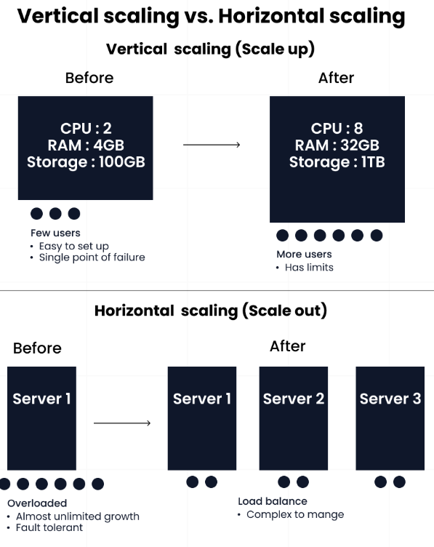

3. What are load balancers, and why are they used?
A load balancer helps manage traffic across multiple servers. Instead of sending all requests to a single server, it distributes them so no server gets overwhelmed.
It works like a traffic director at a busy intersection, guiding cars to different roads so none of them get jammed. In the same way, a load balancer routes requests to the server that can handle them best. It can use simple methods like round robin (sending requests one by one to each server) or smarter methods like sending new requests to the server with the fewest active connections.
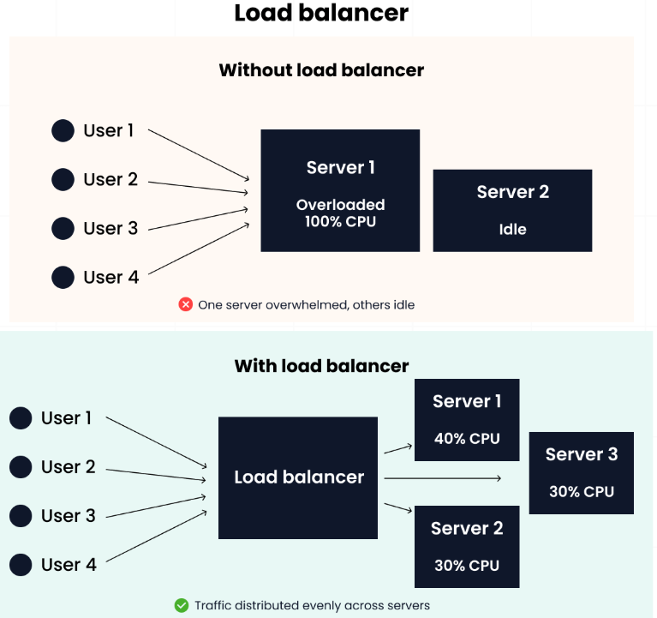
Large-scale applications like Amazon and Instagram rely on load balancers to stay fast and reliable. Without them, a single server could crash under heavy traffic, taking the whole application down.
- Load balancers are useful because they:
- Prevent servers from being overloaded
- Improve reliability by redirecting traffic if a server fails
- Keep performance smooth, even under heavy demand

4.Explain the CAP theorem with examples.
The CAP theorem describes the trade-offs in a distributed system. It states that when your system is spread across multiple servers, you can only guarantee two out of three properties at the same time.
- Consistency (C): Every user sees the same data at the same time.
- Availability (A): Every request gets a response, even if some servers are down.
- Partition tolerance (P): The system continues to work even if parts of the network can’t communicate.
Since network partitions are always possible, most systems must choose between Consistency and Availability.
Examples:
A banking app (CP) may prioritize Consistency and Partition Tolerance. It’s better to be temporarily unavailable than to show the wrong account balance.
A social media platform (AP) like Facebook often chooses Availability and Partition Tolerance. If there’s a network issue, you might see an older feed rather than getting an error.

5.What is caching? Where would you place a cache in a system?
Caching means storing frequently used data in fast memory so it can be retrieved quickly. This reduces response time and lowers the load on the main database.
A simple analogy is keeping your coffee mug on your desk instead of walking to the kitchen every time you need it. It saves time and effort.
Depending on the use case, caching can be placed on:
- Client-side: In the browser, to store static assets like images, stylesheets, or scripts.
- Application-level: In the server’s memory using tools like Redis or Memcached. This is useful for things like user sessions or repeated queries.
- Database-level: To store the results of expensive queries so they don’t need to run repeatedly.
For example, a social media platform like Reddit caches popular posts so that when a thread goes viral, millions of users can see it without overwhelming the database.

6.Explain CDN (Content Delivery Network) and when to use it.
A CDN is a network of servers placed around the world that store and deliver static content like images, videos, and stylesheets. By bringing content geographically closer to users, CDNs reduce latency and speed up delivery.
It’s like having local warehouses in different cities so customers don’t have to wait for packages to ship from far away.
You’ll use CDN when you have:
- Media-heavy sites (videos, images, large files)
- Global users who need a fast loading time

7.What is sharding, and how does it help with scalability?
Sharding means splitting a database into smaller, independent parts called shards, with each shard containing a subset of the data, usually based on a key such as user ID. This makes scaling easier because no single database has to handle all the load. Instead, each shard is responsible for only part of the data.
In practice, a ride-sharing app like Uber could shard data by city, so each region handles only local trips. This keeps queries fast as the user base grows worldwide.

8.When would you choose SQL vs. NoSQL?
The choice between SQL and NoSQL depends on your data and system requirements.
- SQL (e.g., PostgreSQL, MySQL): Best for structured data, complex queries, and transactions that must always be correct. A good example is banking ledgers, where accuracy and consistency are critical.
- NoSQL (e.g., MongoDB, Cassandra): Best for unstructured or semi-structured data, massive scale, and fast writes. Social apps often use NoSQL to store flexible user profiles or logs that don’t fit neatly into tables.
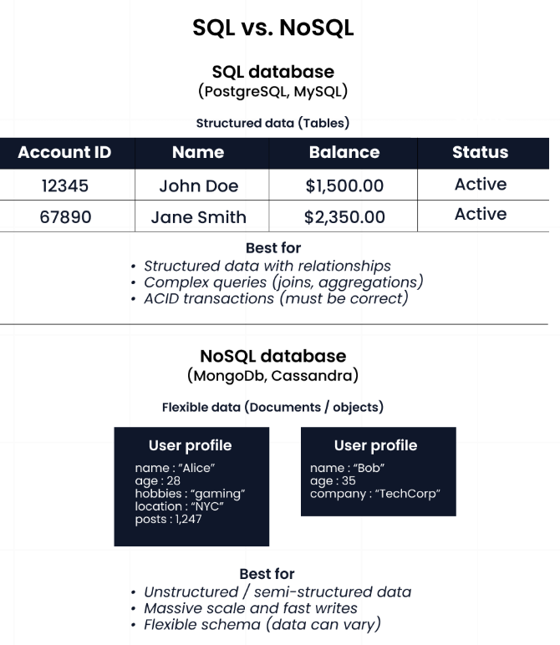
As a rule of thumb, use SQL when you need strong consistency and relational data, and use NoSQL when you need flexibility and scalability.

9.Explain the concept of replication and its types (Master-Slave, Master-Master).
Replication means copying data across multiple servers so the system is more reliable and can handle more reads. It helps improve fault tolerance and scalability, but may introduce trade-offs in complexity.
Types of replication:
- Master-Slave: One server (master) handles all writes, while one or more slaves maintain copies for reads. This setup is simple and great for backups. For example, MySQL often uses this model.
- Master-Master: Multiple servers can handle writes, and they sync with each other. This is more complex because conflicts can happen, but it’s powerful for global apps that need low-latency writes, such as Google Spanner.
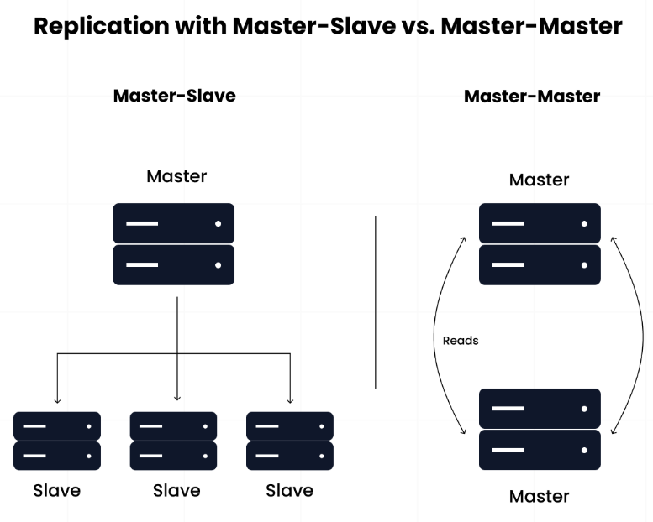

10.What is eventual consistency vs. strong consistency?
Consistency describes how up-to-date the data is across different servers.
- Strong consistency: Every read returns the latest write. This guarantees accuracy but may reduce availability. For example, a stock trading platform must use strong consistency so users don’t oversell shares.
- Eventual consistency: Reads may return slightly outdated data, but all copies catch up eventually. This improves availability and performance. For example, Amazon DynamoDB uses eventual consistency for shopping carts, where a small delay is acceptable.
The key idea is that strong consistency guarantees correctness right away, while eventual consistency favors uptime and speed.

11.How would you design a rate limiter?
A rate limiter controls how many requests a client can make within a given time, protecting systems from abuse like spam or denial-of-service attacks.
Common approaches include:
- Token bucket: Tokens are added at a fixed rate. Each request uses one token; if none remain, the request is blocked.
- Sliding window: Tracks recent requests within a time window and blocks if too many occur too quickly.
In practice, APIs often implement rate limiting in middleware with Redis for distributed counting. When limits are exceeded, requests typically return a 429 Too Many Requests error.

12.How do message queues (e.g., Kafka, RabbitMQ) help in system design?
Message queues let services communicate asynchronously. Instead of calling each other directly, one service sends a message to a queue, and another service processes it later. Popular queuing services are:
- Kafka: Optimized for high-throughput event streams (e.g., logs, analytics)
- RabbitMQ: Great for reliable task queues and guaranteed delivery
For example, an e-commerce order confirmation can be queued so the checkout process doesn’t block if the payment service is slow. This makes systems more resilient under heavy load, such as during Black Friday sales.

13.Explain how a distributed lock works.
A distributed lock ensures that in a system with many servers, only one process at a time can perform a critical action. For example, in a banking app, a distributed lock can prevent two servers from withdrawing money from the same account at the same time.
Tools like Redis (using SETNX with expirations) and ZooKeeper are commonly used to implement distributed locks and avoid race conditions.

14.How do you prevent a cache stampede or cache avalanche?
A cache stampede happens when many requests hit an expired cache at the same time, overloading the database. To prevent this, you can:
- Use early expiration (refresh before expiry).
- Apply request coalescing with mutex locks so only one request updates the cache.
- Pre-warm popular keys before they expire.
- A cache avalanche happens when many cache entries expire at once, causing a sudden load spike. To fix this, you can:
- Use staggered TTLs with random expiration buffers.
- Apply write-through caching so the cache updates alongside the database.
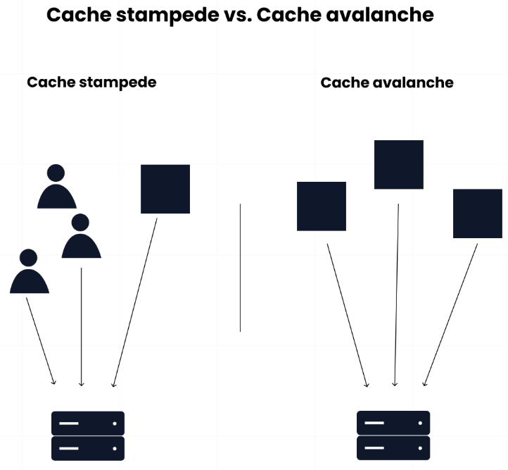

15.What’s the difference between synchronous vs. asynchronous communication in distributed systems?
In synchronous, the sender waits for a response. It’s simple but can cause cascading failures if one service is slow. A common example is an HTTP request between microservices. While in asynchronous, the sender adds a message to a queue or event stream and continues. It’s more resilient and scalable but harder to track end-to-end.
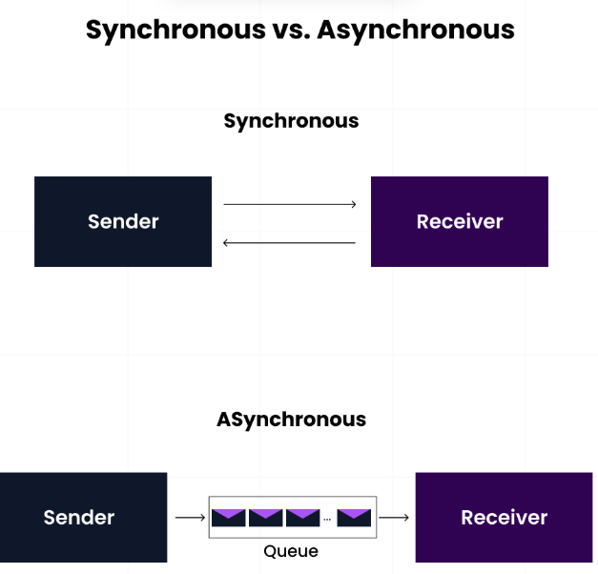
A practical example of asynchronous is how Spotify updates a playlist while the app is still responsive, even if downstream services are busy.

16.How do you handle database schema migrations in large systems?
Schema changes can’t be done all at once in large systems without downtime. Best practices include:

- Using tools like Flyway or Liquibase to track changes with version control
- Rolling out changes in a backward-compatible way (e.g., add new columns before removing old ones)
- Using blue-green deployments or phased rollouts for zero downtime

17.How would you design an API gateway?
An API gateway is a single entry point for clients, sitting in front of microservices. It typically handles:
Authentication and authorization
- Rate limiting
- Request routing and aggregation
- Request and response transformation
- Load balancing
- Key considerations when designing an API gateway include:
- Performance: handle high throughput with low latency.
- Availability: avoid single points of failure.
- Security: protect sensitive data in transit.
- Observability: collect metrics for monitoring.
After the design, deployment can be on a managed service (such as AWS API Gateway or Azure API Management) or self-hosted (using tools like NGINX, Traefik, or Envoy).
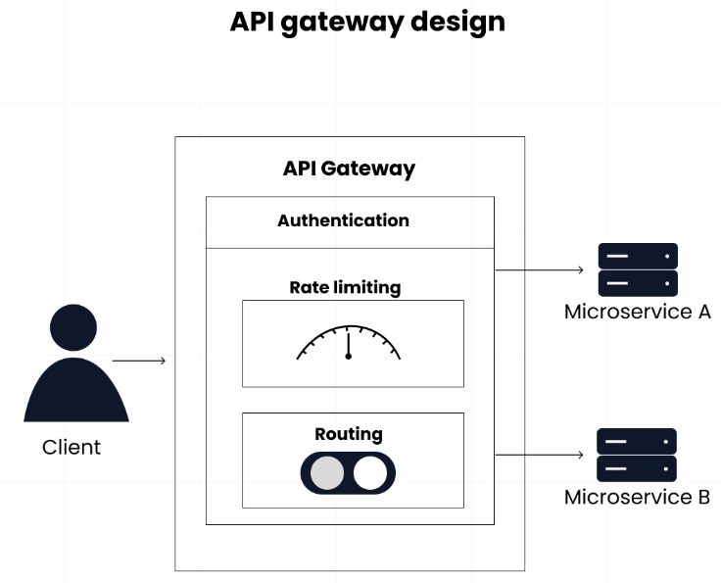

26.Explain the role of reverse proxies.
A reverse proxy sits between clients and backend servers. It can:
- Terminate SSL/TLS connections
- Perform caching and compression
- Load balance requests across servers
- Hide backend details for security
Examples of reverse proxies are Nginx and HAProxy.

27.How would you design a logging and monitoring system for microservices?
A distributed logging and monitoring system must gather data from many services and turn it into actionable insights.
Logging architecture:
- Collection: Each service writes structured logs (e.g., JSON).
- Shipping: Log shippers like Fluentd or Filebeat send logs to an aggregator.
- Storage: Centralized global file storage like Elasticsearch or AWS CloudWatch.
- Analysis: Query and visualization tools like Kibana or Grafana.
Monitoring layers:
Infrastructure: CPU, memory, disk, network usage.
Application: Request rates, response times, error rates.
Business: Metrics such as user signups, transaction volumes, and revenue.

28.Explain how you’d design a notification system (e.g., push, SMS, email).
A notification system delivers updates through multiple channels such as push, SMS, or email.

Key components include:
- Notification service: Central coordinator
- Message queue: Buffer for high-volume notifications
- Channel handlers: Specialized processors for each channel
- Template engine: Generate personalized content
- Delivery tracking: Monitor success/failure rates
When building this system, think about it in stages:
- Ingestion: Use a queue (Kafka, RabbitMQ) to accept and buffer incoming events reliably.
- Processing: Workers consume events from the queue, enrich them if needed, and dispatch them through the right provider (e.g., Twilio for SMS).
- Delivery Guarantees: Implement retries, apply rate limits, and respect user preferences to ensure reliable and personalized delivery.
Combining basic concepts and applying them to real-world problems is important, but interviewers also want to see how you handle complexity at scale. They’re testing your understanding of how systems behave under pressure, how you maintain performance, and how well you can work with systems that people depend on every day.

29.How would you design a collaborative document editing system (like Google Drive or Dropbox)?
A collaborative editor must let multiple users edit the same document in real time without conflicts. Key components include:
- Conflict resolution: Use Operational Transformation (OT) or Conflict-free Replicated Data Types (CRDTs) so simultaneous edits don’t overwrite each other.
- Real-time updates: Use WebSockets for low-latency sync between clients and servers.
- Backend coordination: A pub/sub system like Redis broadcasts updates to all connected users.
- Storage: Use a relational database like PostgreSQL, sharded by document ID for scalability.

30.How would you design a URL shortening service (like bit.ly)?
A URL shortener maps long links to short, shareable keys while handling billions of lookups. Designing it involves:
- Key generation: Use Base62 encoding of an auto-increment ID or generate hashes for uniqueness.
- Storage: Use a distributed NoSQL database like Cassandra for fast writes and reads.
- Performance: Cache popular URLs in Redis to reduce DB lookups.
- Extras: Collect analytics (clicks, referrers, geolocation).

31.How would you design a social media feed system (e.g., Facebook newsfeed, Twitter timeline)?
Feeds must combine real-time updates with ranking at scale. Designing it involves:
- Fan-out on write: Push new posts directly into followers’ feeds. Fast for active users, but expensive for celebrities with millions of followers.
- Fan-out on read: Store posts centrally and build the feed when a user opens it. Saves storage but increases query load.
- Ranking: Use ML models to rank posts by relevance, not just recency.
- Storage and caching: Use sharded databases and in-memory caches for hot feeds.

32.How would you design a search autocomplete system?
Autocomplete suggests results as the user types, so it must be fast and continuously updated. Core components to consider when designing it include:
- Data structure: Use a Trie or inverted index to store prefixes efficiently.
- Search engine: Systems like Elasticsearch can index and return prefix matches quickly.
- Caching: Store common prefixes in Redis for low-latency lookups.
- Error handling: Apply fuzzy matching (e.g., Levenshtein distance) to handle typos.

33.How do you design a payment processing system (like Stripe/PayPal)?
Payments require security, reliability, and regulatory compliance. Building a payment system will cover:
- Microservices: Separate services for authentication, transaction handling, fraud detection, and notifications.
- Asynchronous workflows: Use queues for retries and idempotency to prevent duplicate charges.
- Compliance: Follow PCI standards and encrypt sensitive data.
- Integration: Connect with banks and card networks via APIs.
- Idempotency: Ensure retries don’t double-charge users.

34.How would you design an e-commerce checkout system?
Checkout is mission-critical and must be both consistent and resilient. Designing it entails:
- Atomic operations: Use saga patterns or two-phase commit (2PC) to ensure cart, payment, and inventory remain in sync.
- Queues: Offload order fulfillment (shipping, emails) to async workers.
- Inventory locking: Temporarily hold stock during checkout to avoid overselling.

35.How do you design a real-time chat system (like WhatsApp/Slack)?
Global chat services handle billions of messages daily while ensuring instant delivery, conversation history, and multimedia support. The architecture includes:
- Transport: WebSockets for persistent, bidirectional communication.
- Storage: Write messages to distributed storage (e.g., Cassandra for time-series data).
- Group chats: Use pub/sub systems to broadcast messages to multiple users.
- Scale: Use partitioning and sharding for chat rooms with millions of users.
- Security: End-to-end encryption for privacy.

35.How do you design a recommendation system (e.g., Netflix, Amazon)?
Recommendation systems analyze user behavior and content attributes to suggest relevant items, directly impacting engagement and revenue. Designing a system that caters to this need requires:
- Algorithms: Collaborative filtering (similar users/items) or content-based models (item attributes).
- Batch layer: Offline training with Spark or Hadoop on historical data.
- Real-time layer: Update recommendations with Kafka streams based on new activity.
- Serving layer: Expose recommendations through a fast API with caching.

36.How do you design a video streaming service (like YouTube/Netflix)?
Video streaming platforms handle massive amounts of video content, global distribution, and millions of concurrent viewers while maintaining high quality and minimal buffering. It needs to balance storage, delivery, and adaptive playback. Designing it involves:
- Encoding: Transcode videos into multiple formats and bitrates.
- Storage: Store in object stores (e.g., S3) with metadata in sharded databases.
- Delivery: Use CDNs for global distribution.
- Adaptive playback: Use HLS or MPEG-DASH to adjust video quality based on bandwidth.

37.How would you design a ridesharing app backend (Uber/Lyft)?
Ridesharing platforms coordinate millions of drivers and riders in real-time while optimizing routes, pricing, and resource allocation. Architecting a ridesharing platform includes:
- Geospatial indexing: Use data structures like Quadtrees or GeoHash for nearby driver searches.
- Matching service: Match riders with drivers in real time, factoring in distance, ETA, and surge pricing.
- Messaging: Use WebSockets or push notifications for trip updates.
- Scalability: Shard by city or region for local performance.

38. How do you design database schema for millions of users without performance issue?
Start with indexing –
Use proper primary keys and indexes for columns you frequently search or filter.
No index = slow queries as your data grows.
2️⃣ Normalize first, denormalize when needed –
• Normalize to avoid duplicate data and keep storage lean.
• Denormalize (duplicate some data) if joins become too slow at scale.
3️⃣ Partition or shard data –
Split huge tables by region, user ID ranges, or time so queries touch smaller chunks.
4️⃣ Use caching smartly –
• Redis/Memcached for frequently accessed data
• Avoid hitting the DB for every read
5️⃣ Archive old data –
• Keep the active database lean
• Move old logs or inactive users to cold storage
💡 Pro tip:
Always design for 10x growth. If your schema struggles at 100k users, it will collapse at 1M.

39. How do you handle secure connection between multiple microservices?
🔐 Common ways to do it:
• mTLS (Mutual TLS): Both client and server verify each other’s identity before exchanging data.
• Service Mesh (Istio, Linkerd): Handles encryption, service-to-service authentication, and policies automatically.
• API Gateway: Acts as a secure entry point, handling auth tokens and rate-limiting before traffic reaches services.
• JWT or OAuth Tokens: Each request is verified so only trusted services can talk to each other.
⚠️ Without this, a single compromised service can become an open door to your entire system.

40. How do you decide between vertical scaling and horizontal scaling for backend?
Choosing between vertical scaling and horizontal scaling depends on your system’s growth, budget, and performance needs.
✅Vertical Scaling (Scaling Up)
• Add more CPU, RAM, or storage to your existing server.
• Simple to implement, no app changes required.
• But has a hard limit—you can’t scale forever.
• Risk: single point of failure (if that server goes down, everything is down).
✅Horizontal Scaling (Scaling Out)
• Add more servers/nodes and distribute the load.
• Improves reliability (one server down ≠ system down).
• Works great for high traffic apps.
• But it’s complex — you need load balancers, data replication, and often changes in your app architecture.
⚖️ Rule of Thumb:
• Start with vertical scaling — it’s cheaper & simpler.
• Move to horizontal scaling when traffic grows beyond what a single machine can handle.
• Modern systems usually mix both.

41. How do you ensure cache consistency when frequently data changes?
Keeping cache consistency is one of the trickiest challenges when your data changes often — because stale data can break user trust faster than downtime.
Here’s how to handle it like a pro:
1️⃣ Short TTL (Time-to-Live) — Keep cached items for just enough time to benefit from speed, but refresh before they go stale. Example: 30–60 seconds for highly dynamic data.
2️⃣ Cache Invalidation Strategies:
• Write-through → Write to cache + database together, so they’re always in sync.
• Write-behind → Write to cache first, update DB asynchronously (faster, but risk of brief inconsistency).
• Explicit purge → Delete or update cache whenever the source data changes.
3️⃣ Event-driven cache updates — Use a message broker (Kafka, RabbitMQ, Redis Pub/Sub) so that when data changes, all caches listening to that topic get updated instantly.
4️⃣ Versioning / ETags — Store a version number or hash for each cached object. Before serving, check if the version matches the latest in the DB.
5️⃣ Read-through caching — If data is missing or stale, fetch fresh from DB, store in cache, then serve — keeps cache self-healing.
Golden rule: Never blindly trust your cache — have a freshness check if the cost of stale data is high.

42. How do you cache data effectively using redis and memcached?
To cache data effectively with Redis or Memcached, focus on 3 key points:
1️⃣ Cache the right data → Things that are read often but don’t change constantly (user sessions, product listings, dashboards).
2️⃣ Set a TTL (time-to-live) → Prevents serving stale data forever and keeps your cache healthy.
3️⃣ Pick the right tool →
• Use Memcached for simple key-value lookups with ultra-fast performance.
• Use Redis if you need more advanced features like pub/sub, data structures (lists, sets), persistence, or distributed locks.
⚡ Pro tip: Always design your app to gracefully fall back to the database if the cache is unavailable (cache-aside pattern is a classic).

43. When do you split monolith frontend to microfrontends?
You should split a monolithic frontend into microfrontends when your application:

🔸 Has grown so large that it’s slowing down your teams
🔸 Needs independent development, testing, and deployment per module
🔸 Involves multiple teams working on different features (like dashboard, payments, admin)
🔸 Is facing merge conflicts or long CI/CD cycles due to one shared codebase
🔸 Wants to experiment or migrate to different tech stacks (like React + Vue in the same app)
🎯 The goal? Decouple teams and scale faster without stepping on each other’s code.
But beware — microfrontends add operational complexity, so don’t choose them just to follow trends. Choose them when the pain of monolith maintenance exceeds the cost of splitting.

44. How do you prevent a single slow service from causing cascading failures in microservices?
To prevent a single slow service from causing cascading failures in a microservices setup:
1. ⏱️ Timeouts – Always set timeouts. Never wait forever for a response.
2. 🔁 Retry with Backoff – Retry smartly, not blindly. Avoid overload.
3. 🚫 Circuit Breakers – Stop calls to failing services temporarily.
4. 🧱 Bulkheads – Isolate services to contain failure.
5. 📊 Monitoring – Detect slowness before it becomes disaster.

45. How do you decide between SQL and NoSql in new project?
Choosing between SQL vs NoSQL can make or break your project’s scalability and performance.
Here’s how I decide 👇
1️⃣ Choose SQL (Relational DBs like MySQL / PostgreSQL) if:
• Your data is structured and relational (e.g., users ↔ orders)
• You need ACID transactions (banking, payments)
• Schema rarely changes and you want strong consistency
💡 Example: E-commerce, financial apps, inventory management
2️⃣ Choose NoSQL (MongoDB, DynamoDB, Redis) if:
• Your data is unstructured or semi-structured (JSON, logs, events)
• You need flexibility in schema or fast iteration
• High read/write scale matters more than strict consistency
💡 Example: Real-time analytics, chat apps, IoT, content feeds
3️⃣ Hybrid Approach
• Many real-world systems use both → SQL for critical relational data + NoSQL for high-speed, flexible workloads.
Pro Tip:
Start with SQL if unsure → migrate specific modules to NoSQL later for scale.

46. How do you handle WebSocket reconnection in a real-time dashboard?
WebSockets are great for real-time dashboards, but they can disconnect due to network drops, server restarts, or user switching tabs.
Here’s how I handle smooth reconnections 👇
1️⃣ Auto-Reconnect Logic
• Implement a retry mechanism with exponential backoff.
• Example: Try reconnecting after 1s → 2s → 4s → max 30s.
2️⃣ Heartbeat / Ping-Pong
• Send periodic ping messages to detect dead connections.
• If no pong received, trigger reconnect.

3️⃣ Queue Messages During Disconnect
• If dashboard needs to send data, queue it until WebSocket is back.
4️⃣ Handle UI Gracefully
• Show a “Reconnecting…” toast or indicator.
• Avoid sudden blank states to keep UX smooth.
5️⃣ Server Support
• Ensure server accepts resumed sessions or re-authenticates tokens to avoid full reload.
💡 Pro Tip:
Combine WebSocket + fallback to polling for mission-critical dashboards to never miss data.

47.Your webapp loads fast on WiFi but crawls on 4G. What secretly killing your performance?
Your webapp isn’t really “slow” on 4G… it’s just choking on hidden performance killers. 🚦
Here’s what’s secretly hurting you:
1️⃣ Huge bundle sizes –
Your JS, CSS, and images are probably too heavy. On WiFi, it feels okay… but 4G exposes every KB.
2️⃣ Too many network requests –
Each API call, font, or image makes the phone wait for multiple round trips. On slower networks, this adds seconds.
3️⃣ No proper caching –
If the browser can’t reuse files from previous visits, it downloads everything again.
4️⃣ Render-blocking scripts –
That one JS library you imported for a tiny feature might be stopping the entire page from showing up.
5️⃣ Images not optimized –
Serving a 5MB banner image to a mobile user is like sending a truckload of files over a narrow street.
💡 Pro tip:
• Compress & lazy-load images 🖼
• Split your JS into smaller chunks ⚡
• Cache static assets aggressively 🔄
• Use Lighthouse/Pagespeed to see what’s really slowing you down
If your app feels fast on WiFi but slow on 4G… it’s not the internet’s fault—it’s your frontend diet,

48. One microservice is very slow due to external API calls. How will you optimize it?
⚡ Optimizing a Slow Microservice (Due to External API Calls) ⚡
Use a combination of caching, async processing, and resilience patterns:
🗄️ 1. Caching Responses
• Cache frequent API responses using Redis or in-memory cache
• Set proper TTL ⏳ to avoid stale data
⚡ 2. Asynchronous / Parallel Calls
• Call external APIs in parallel instead of sequential
• Use message queues (Kafka / RabbitMQ) for non-critical async calls
🛡️ 3. Retry & Circuit Breaker Pattern
• Implement circuit breakers (Resilience4j / Hystrix) to prevent cascading failures
• Use retry with exponential backoff for temporary API issues
🔄 4. Fallbacks & Graceful Degradation
• Provide cached / fallback data if the API is slow or down
• Return partial responses to keep the system responsive
🧱 5. Bulkhead & Timeout
• Set timeouts for all external API calls ⏱️
• Use bulkheads to isolate slow APIs from impacting other services
📦 6. Data Replication / Pre-Fetching
• Pre-fetch or replicate frequent data in your own DB for faster access
✅ Smart combo of caching + async + resilience
can bring 2x–10x performance improvement in real-world microservices

49. What is System Design?
The process of establishing system aspects such as modules, architecture, components and their interfaces, and data for a system based on specified requirements is known as system design. It is the process of identifying, creating, and designing systems that meet a company’s or organization’s specific objectives and expectations. Systems design is more about system analysis, architectural patterns, APIs, design patterns, and glueing it all together than it is about coding. Because your application will be able to handle the architectural load, designing your system adequately for the requirements of your application will eliminate unnecessary costs and maintenance efforts, as well as provide a better experience for your end-users.

50. What is CAP theorem?
CAP(Consistency-Availability-Partition Tolerance) theorem says that a distributed system cannot guarantee C, A and P simultaneously. It can at max provide any 2 of the 3 guarantees. Let us understand this with the help of a distributed database system.
- Consistency: This states that the data has to remain consistent after the execution of an operation in the database. For example, post database updation, all queries should retrieve the same result.
- Availability: The databases cannot have downtime and should be available and responsive always.
- Partition Tolerance: The database system should be functioning despite the communication becoming unstable.
The following image represents what databases guarantee what aspects of the CAP Theorem simultaneously. We see that RDBMS databases guarantee consistency and Availability simultaneously. Redis, MongoDB, Hbase databases guarantee Consistency and Partition Tolerance. Cassandra, CouchDB guarantees Availability and Partition Tolerance.

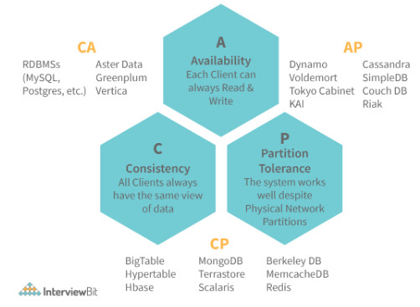

51. How is Horizontal scaling different from Vertical scaling?
- Horizontal scaling refers to the addition of more computing machines to the network that shares the processing and memory workload across a distributed network of devices. In simple words, more instances of servers are added to the existing pool and the traffic load is distributed across these devices in an efficient manner.
- Vertical scaling refers to the concept of upgrading the resource capacity such as increasing RAM, adding efficient processors etc of a single machine or switching to a new machine with more capacity. The capability of the server can be enhanced without the need for code manipulation.
This has been demonstrated in the image below:
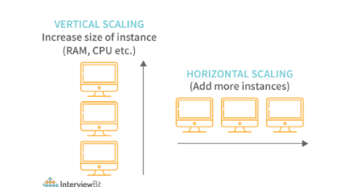
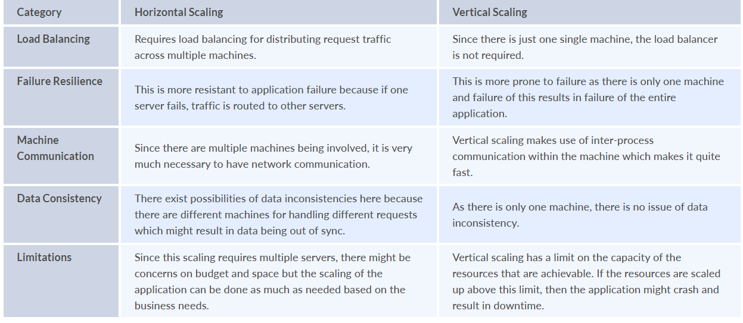
52. What do you understand by load balancing? Why is it important in system design?
Load balancing refers to the concept of distributing incoming traffic efficiently across a group of various backend servers. These servers are called server pools. Modern-day websites are designed to serve millions of requests from clients and return the responses in a fast and reliable manner. In order to serve these requests, the addition of more servers is required. In such a scenario, it is essential to distribute request traffic efficiently across each server so that they do not face undue loads. Load balancer acts as a traffic police cop facing the requests and routes them across the available servers in a way that not a single server is overwhelmed which could possibly degrade the application performance.
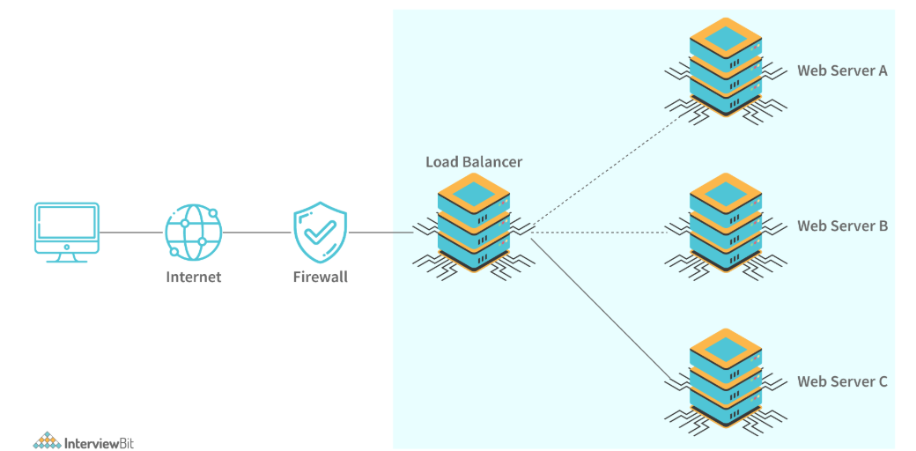
When a server goes down, the load balancer redirects traffic to the remaining available servers. When a new server gets added to the configuration, the requests are automatically redirected to it. Following are the benefits of load balancers:
- They help to prevent requests from going to unhealthy or unavailable servers.
- Helps to prevent resources overloading.
- Helps to eliminate a single point of failure since the requests are routed to available servers whenever a server goes down.
- Requests sent to the servers are encrypted and the responses are decrypted. It aids in SSL termination and removes the need to install X.509 certificates on every server.
- Load balancing impacts system security and allows continuous software updates for accomodating changes in the system.

53. What is Sharding?
Sharding is a process of splitting the large logical dataset into multiple databases. It also refers to horizontal partitioning of data as it will be stored on multiple machines. By doing so, a sharded database becomes capable of handling more requests than a single large machine. Consider an example - in the following image, assume that we have around 1TB of data present in the database, when we perform sharding, we divide the large 1TB data into smaller chunks of 256GB into partitions called shards.
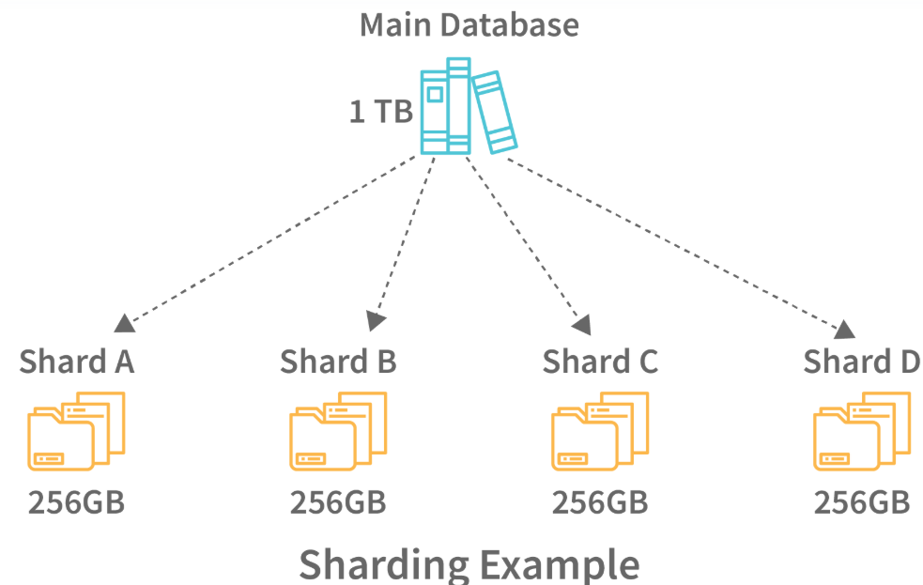
Sharding helps to scale databases by helping to handle the increased load by providing increased throughput, storage capacity and ensuring high availability.

54. How is NoSQL database different from SQL databases?
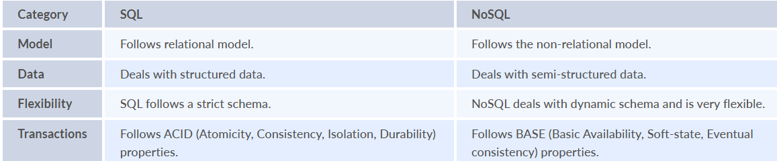

55. How is sharding different from partitioning?
Database Sharding - Sharding is a technique for dividing a single dataset among many databases, allowing it to be stored across multiple workstations. Larger datasets can be divided into smaller parts and stored in numerous data nodes, boosting the system’s total storage capacity. A sharded database, similarly, can accommodate more requests than a single system by dividing the data over numerous machines. Sharding, also known as horizontal scaling or scale-out, is a type of scaling in which more nodes are added to distribute the load. Horizontal scaling provides near-limitless scalability for handling large amounts of data and high-volume tasks.
Database Partitioning - Partitioning is the process of separating stored database objects (tables, indexes, and views) into distinct portions. Large database items are partitioned to improve controllability, performance, and availability. Partitioning can enhance performance when accessing partitioned tables in specific instances. Partitioning can act as a leading column in indexes, reducing index size and increasing the likelihood of finding the most desired indexes in memory. When a large portion of one area is used in the resultset, scanning that region is much faster than accessing data scattered throughout the entire table by index. Adding and deleting sections allows for large-scale data uploading and deletion, which improves performance. Data that are rarely used can be uploaded to more affordable data storage devices.
The following table lists the differences between sharding and partitioning:
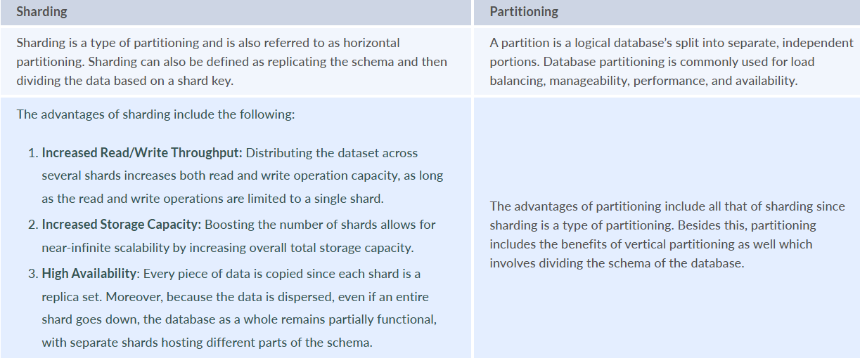

56. How is performance and scalability related to each other?
A system is said to be scalable if there is increased performance is proportional to the resources added. Generally, performance increase in terms of scalability refers to serving more work units. But this can also mean being able to handle larger work units when datasets grow. If there is a performance problem in the application, then the system will be slow only for a single user. But if there is a scalability problem, then the system may be fast for a single user but it can get slow under heavy user load on the application.

57. What is Caching? What are the various cache update strategies available in caching?
Caching refers to the process of storing file copies in a temporary storage location called cache which helps in accessing data more quickly thereby reducing site latency. The cache can only store a limited amount of data. Due to this, it is important to determine cache update strategies that are best suited for the business requirements. Following are the various caching strategies available:
Cache-aside: In this strategy, our application is responsible to write and read data from the storage. Cache interaction with the storage is not direct. Here, the application looks for an entry in the cache, if the result is not found, then the entry is fetched from the database and is added to the cache for further use. Memcached is an example of using this update strategy.
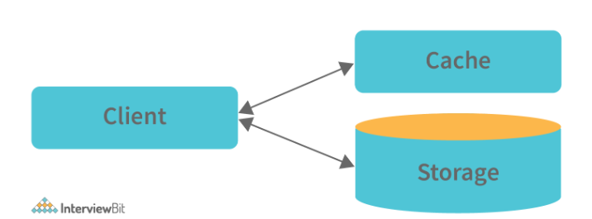
Cache-aside strategy is also known as lazy loading because only the requested entry will be cached thereby avoiding unnecessary caching of the data. Some of the disadvantages of this strategy are:
- In cases of a cache miss, there would be a noticeable delay as it results in fetching data from the database and then caching it.
- The chances of data being stale are more if it is updated in the database. This can be reduced by defining the time-to-live parameter which forces an update of the cache entry.
- When a cache node fails, it will be replaced by a new, empty node which results in increased latency.
- Write-through: In this strategy, the cache will be considered as the main data store by the system and the system reads and writes data into it. The cache then updates the database accordingly as shown in the database.
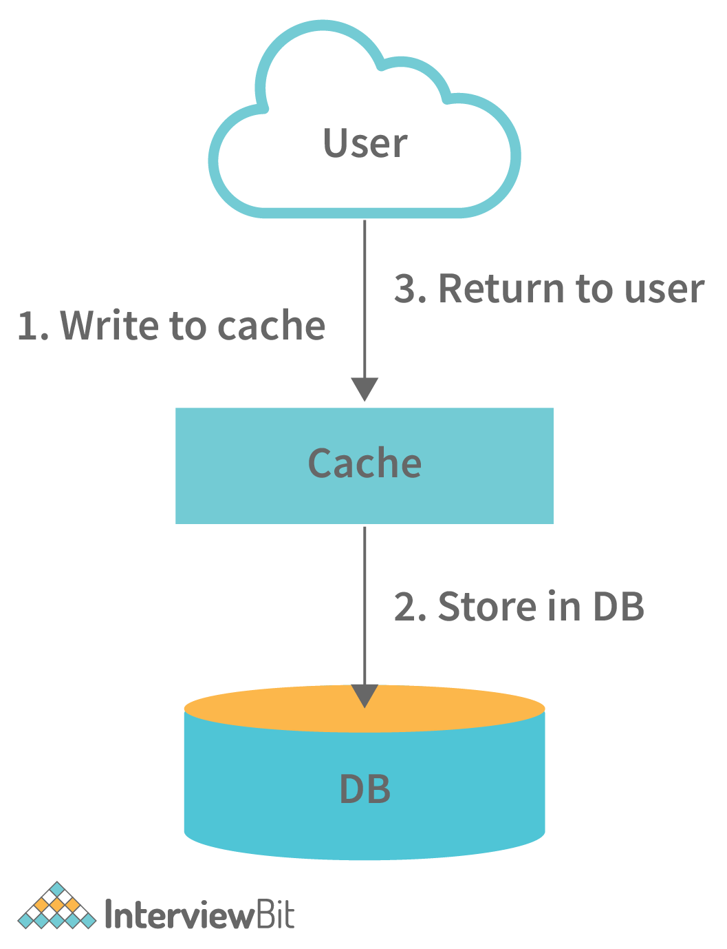
- The system adds or updates the entry in the cache.
- The cache synchronously writes entries to the database. This strategy is overall a slow operation because of the synchronous write operation. However, the subsequent reads of the recently written data will be very fast. This strategy also ensures that the cache is not stale. But, there are chances that the data written in the cache might never be read. This issue can be reduced by providing appropriate TTL.
- Write-behind (write-back): In this strategy, the application does the following steps:
  - Add or update an entry in the cache
  - Write the entry into the data store asynchronously for improving the write performance. This is demonstrated in the image below:
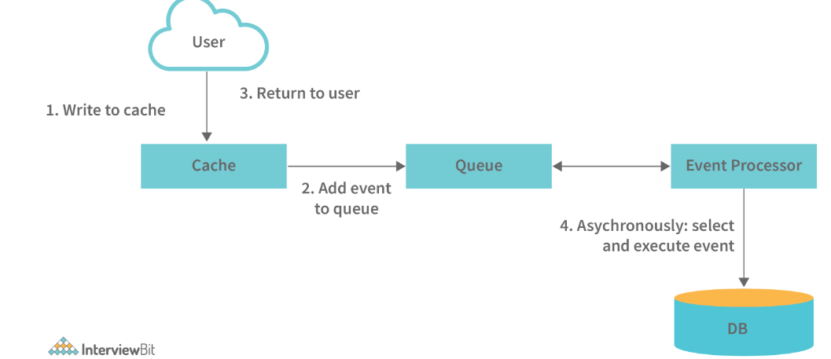
The main disadvantage of this method is that there are chances of data loss if the cache goes down before the contents of the cache are written into the database.
Refresh-ahead: Using this strategy, we can configure the cache to refresh the cache entry automatically before its expiration.

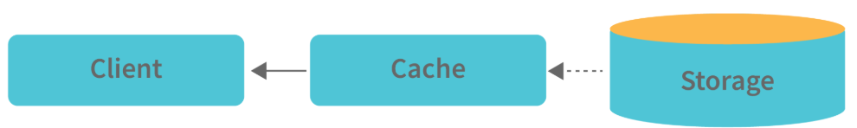
58. What are the various Consistency patterns available in system design?
Consistency from the CAP theorem states that every read request should get the most recently written data. When there are multiple data copies available, there arises a problem of synchronizing them so that the clients get fresh data consistently. Following are the consistency patterns available:
- Weak consistency: After a data write, the read request may or may not be able to get the new data. This type of consistency works well in real-time use cases like VoIP, video chat, real-time multiplayer games etc. For example, when we are on a phone call, if we lose network for a few seconds, then we lose information about what was spoken during that time.
- Eventual consistency: Post data write, the reads will eventually see the latest data within milliseconds. Here, the data is replicated asynchronously. These are seen in DNS and email systems. This works well in highly available systems.
- Strong consistency: After a data write, the subsequent reads will see the latest data. Here, the data is replicated synchronously. This is seen in RDBMS and file systems and are suitable in systems requiring transactions of data.

59. What do you understand by Content delivery network?
Content delivery network or in short CDN is a globally distributed proxy server network that serves content from locations close by to the end-users. Usually, in websites, static files like HTML, CSS, JS files, images and videos are served from CDN.
Using CDN in delivering content helps to improve performance:
- Since users receive data from centres close to them as shown in the image below, they don't have to wait for long.
- Load on the servers is reduced significantly as some of the responsibility is shared by CDNs.
There are two types of CDNs, they are:
- Push CDNs: Here, the content is received by the CDNs whenever changes occur on the server. The responsibility lies in us for uploading the content to CDNs. Content gets updated to the CDN only when it is modified or added which in turn maximises storage by minimising the traffic. Generally, sites with lesser traffic or content work well using push CDNs.
- Pull CDNs: Here new content is grabbed from the server when the first user requests the content from the site. This leads to slower requests for the first time till the content gets stored/cached on the CDN. These CDNs minimizes space utilized on CDN but can lead to redundant traffic when expired files are pulled before they are changed. Websites having heavy traffic work well when used with pull CDNs.

60. What do you understand by Leader Election?
In a distributed environment where there are multiple servers contributing to the availability of the application, there can be situations where only one server has to take lead for updating third party APIs as different servers could cause problems while using the third party APIs. This server is called the primary server and the process of choosing this server is called leader election. The servers in the distributed environment have to detect when the leader server has failed and appoint another one to become a leader. This process is most suitable in high availability and strong consistency based applications by using a consensus algorithm.

61. How do you answer system design interview questions?
Ask questions to the interviewer for clarification: Since the questions are purposefully vague, it is advised to ask relevant questions to the interviewer to ensure that both you and the interviewer are on the same page. Asking questions also shows that you care about the customer requirements.
Gather the requirements: List all the features that are required, what are the common problems and system performance parameters that are expected by the system to handle. This step helps the interviewer to see how well you plan, expect problems and come up with solutions to each of them. Every choice matters while designing a system. For every choice, at least one pros and cons of the system needs to be listed.
Come up with a design: Come up with a high-level design and low-level design solutions for each of the requirements decided. Discuss the pros and cons of the design. Also, discuss how they are beneficial to the business.
The primary objective of system design interviews is to evaluate how well a developer can plan, prioritize, evaluate various options to choose the best possible solution for a given problem.

62. What are some of the design issues in distributed systems?
Following are some of the issues found in distributed systems:
- Heterogeneity: The Internet allows applications to run over a heterogeneous collection of computers and networks. There would be different types of networks and the differences are masked by the usage of standard Internet protocols for communicating with each other. This becomes an issue while designing distributed applications
- Openness: Openness represents the measure by which a system can be extended and re-implemented in different ways. In distributed systems, it specifies the degree to which new sharing services can be added and made available for client usage.
- Security: The information maintained in distributed systems need to be secure as they are valuable to the users. The confidentiality, availability and integrity of the distributed systems have to be maintained and this sometimes becomes a challenge.
- Scalability: A system is scalable if it remains effective when there is a significant increase in the request traffic and resources. Designing a distributed system involves planning well in advance how well the system can be made scalable under varying user loads.
- Failure Handling: In a distributed environment, the failures are partial, meaning if some components fail, others would still function. It becomes challenging to handle these failures as it involves identifying right components where the failures occur.
63. Design Uber, Ola or Lyft type of systems.
These platforms help user request rides and the driver picks them up from the location and drop them at the destination selected by the user.
What are some of the required features?
- Real-time service for booking rides
- Should have the capability of assigning rides that lets the user reach the destination fast.
- Show the ETA (Estimated Time of Arrival) of the driver after booking the ride and once the ride has been started, show the ETA of the vehicle arriving at the destination.
What are some of the common problems encountered?
- How to store geographical locations for drivers always on move?
- How to assign drivers to the customers efficiently?
- How do you calculate the ETA of the driver arrival or the destination arrival?
Possible tips for consideration:
- Make use of the microservices concept with fast databases for booking rides faster.
- Evaluate Dispatch System for assigning drivers to the users.

64. Design ATM system.
ATMs are used for depositing and withdrawing money from customers. It is also useful for checking the account balance.
What are some of the required features?
- Each user should have at least one bank account that is linked to the card for performing transactions.
- ATM to authenticate the user based on 4 digit PIN associated with the card.
- User to perform only one transaction at a given time.
What are some of the common problems encountered?
- What happens during transaction timeout?
- What happens if the money is deducted from the bank account but the user hasn't received it from the machine?
Possible tips for consideration:
- Divide the problem into different entities like Card, Card Reader etc and establish a relationship between each of the entities.

65. Design Web Crawler.
The Web crawler is a search engine-related service like Google, DuckDuckGo and is used for indexing website contents over the Internet for making them available for every result.
What are some of the Required Features?
- Design and develop a Scalable service for collecting information from the entire web and fetching millions of web documents.
- Fresh data has to be fetched for every search query.
What are some of the common problems encountered?
- How to handle the updates when users are typing very fast?
- How to prioritize dynamically changing web pages?
Possible tips for consideration:
- Look into URL Frontier Architecture for implementing this system.
- Know how crawling is different from scraping.

66. Design a traffic control system.
Generally, in a traffic control system, we see that the lights transition from RED To GREEN, GREEN to ORANGE and then to RED.
What are some of the Required Features?
- Transition traffic lights based on the conventions.
What are some of the common problems encountered?
- Determine the time interval for which the state of the traffic lights has to change.
What happens in worst-case scenarios where the state is wrongly shown?
Possible tips for consideration:
- Make use of state design patterns and scheduling algorithms for the transition of the state from one colour to another.

67. Design Tic-Tac-Toe game.
Tic-tac-toe game involves two players where one player chooses 0 and the other player chooses X for marking the cells. The player who fills a row/column/diagonal with their selected character wins.
What are some of the Required Features?
- Support 2 player game where one player can be a computer.
- Design algorithm to calculate the win and loss results.
What are some of the common problems encountered?
- What happens if both players play optimally?
- How to decide the winning strategy?
Possible tips for consideration:
- If one player is a computer, then make use of the rand() method for ensuring moves are completely random.

68. Design Netflix.
Netflix is a video streaming service.
What are some of the Required Features?
- Uninterrupted video streaming to be made available for the users.
- Likes and reviews of videos.
- Recommend new videos.
- Support high traffic of users.
What are some of the common problems encountered?
- Is it acceptable to have lags while uploading videos?
- What happens if many users are accessing the same video concurrently?
Possible tips for consideration:
- Make use of cloud technology to store and transmit video data
- There are three components of Netflix: OC (Content Delivery Network), Backend database, Client device for accessing the application.

69. Design a type-ahead search engine service.
This service partially completes the search queries by displaying n number of suggestions for completing the query that the user intended to search.
What are some of the Required Features?
- Service has to match partial queries with popularly searched queries.
- The system has to display n number of suggestions (say 5, for example) based on the written query.
- The suggestions have to be updated based on the query updation.
What are some of the common problems encountered?
- How to update the suggestions without much latency?
- How to determine the most likely suggestion?
- Are the suggestions adapting to the user’s search results?
- When do the suggestions appear? Is it updated on the fly or once the user stops writing?
Possible tips for consideration:
- Evaluate the usage of natural language processing for anticipating the next characters.
- Markov chain rule for ranking the probabilities of top queries.

70. How do you design global file storage and file sharing services like Google Drive, Dropbox etc?
What are some of the Required Features?
- Users should be able to upload, delete, share and download files over the web.
- File updates should be synced across multiple devices.
What are some of the common problems encountered?
- Where to store the files?
- How can you handle updates? Should the files be re-uploaded or does just the modified version has to be updated?
- How to handle updation of two documents at the same time?
Possible tips for consideration:
- Consider using chunking for splitting files into multiple sections for supporting re-uploads of a particular section rather than the whole file.
- Make use of cloud storage for storing the files.

71. Design an API Rate Limiter system for GitHub or Firebase sites.
API Rate Limiters limit the API calls that a service receives in a given time period for avoiding request overload. This question can start with the coding algorithm on a single machine to the distributed network.

What are some of the Required Features?
- What is the required request count per hour or second? Let us assume that the requirement can be 10 requests per second.
- Should the limiter notify the user if the requests are blocked?
- The limiter should handle traffic suitable according to the scale.
What are some of the common problems encountered?
- How to measure the requests per given time?
- How to design the rate limiter for the distributed systems when compared to a local system?
Possible tips for consideration:
- Evaluate the usage of sliding time windows for avoiding hourly resets.
- Try using a counter integer instead of a request for saving space.

72. How do you design a recommendation system?
Recommendation systems are used for helping users identify what they want efficiently by assisting them by offering various choices and alternatives based on their history or interests.
What are some of the Required Features?
- Discuss what kind of recommendation system is required - whether it is for movies, e-commerce websites, songs etc.
What are some of the common problems encountered?
- Figure out how to recommend fresh and relevant content in real-time.
Possible tips for consideration:
- Discuss how to use the Eval component for understanding the working of the system.
- Discuss how to train a collaborative filtering approach.

73. Design a parking lot system?
What are some of the Required Features?
- The parking lot can have multiple levels where each level has multiple rows for parking spots.
- The parking lot can support parking for cars, buses, motorcycles hence spots can be of multiple sizes.
- Consider the parking lot capacity at the time of designing the system.
- Design appropriate pricing for each parking spot.
What are some of the Common Problems encountered?
- What should happen to the parking lot system if every spot is occupied?
- Assigning parking lot spots of smaller size to vehicles of a bigger size.
Possible tips for consideration:
- Think of an algorithm for assigning an appropriate parking spot to a vehicle.
- Think of different entities required for designing the system.

74. Design Facebook’s newsfeed system.
Facebook’s newsfeed allows users to see what is happening in their friend's circle, liked pages and groups followed.
What are some of the Required Features?
- Generate newsfeed using posts from other system entities that the user follows.
- Newsfeed posts can be of text, image, audio or video format.
- Append new posts to the user’s newsfeed in close to real-time.
What are some of the Common Problems encountered?
- What happens if the new post sees a lot of latency to get appended to the news feed?
- Can the algorithm handle sudden user load?
- What posts should take priority for displaying in the news feed?
Possible tips for consideration:
- Evaluate the process of fanout for publishing posts to the followers
- Check how sharding can be achieved efficiently for handling heavy user load. The feed data of a user shouldn't be put into multiple servers. Instead, sharding can be done on user ids.

75. Design a forum-like systems like Quora, Reddit or HackerNews.
These sites are meant for posting questions and answering them, showing newsfeed highlighting popular questions based on tags and related topics.
What are some of the Required Features?
- Users should be able to create public posts and apply tags to them.
- Posts should be sortable based on tags.
- Post comments in real-time by users.
- Display posts on newsfeed based on followed tags.
What are some of the Common Problems encountered?
- Should it be just a web application?
- Where to store the uploaded images and links?
- How can you determine the related tags?
- How can you distribute posts across a server network?
Possible tips for consideration:
- Check on using SQL database for mapping relational data between users, posts, comments, likes, tags, posts etc.
- Incorporate multithreading and load balancer for supporting high traffic.
- Make use of sharding for distributing the data across different systems.
- Incorporate machine learning algorithms for finding correlations between the tags.

76. How do you design a URL shortening service like TinyURL or bit.ly?
TinyURL or bit.ly takes a long URL and generates a new unique short URL. These systems are also capable of taking the shortened URL and returning the original full URL.
What are some of the Required Features?
- Generate a short URL having a length shorter than the original URL.
- Store the original URL and map it to the shortened one.
- Allow redirects in the shortened URLs.
- Support custom names for short URLs.
- Handle multiple requests at the same time.
What are some of the Common Problems encountered?
- What if two users input the same custom URL?
- What happens if there are more user load than expected?
- How do you regulate the database storage space?
Possible tips for consideration:
- The concept of hashing can be used for linking original and new URLs.
- REST API can be used for balancing high traffic and handling front-end communication.
- Multithreading concept for handling multiple requests at the same time.
- NoSQL databases for storing original URLs.

77. Design a global chat service like Whatsapp or a facebook messenger.
What are some of the required features?
- Allow users to chat over the internet.
- Provide support for one-on-one and group chats.
- Messages need to be stored for better viewing.
- Messages need to be encrypted for security purposes.
What are some of the common problems that can be encountered?
- What would happen to a message if it is sent without an internet connection?
- Will encrypting and decrypting increase the latency?
- How are the messages sent and notified to the device?
Possible Tips for consideration:
- Split database schema into multiple tables such as user table, chat table, massage table etc.
- Make use of web sockets for bi-directional communication between the device and the server.
- Make use of push notifications for notifying the members even if they are online.

